**Lecture 3**

**What is PL/SQL?**

* PL/SQL Stands for Procedural Language extension to SQL
* It is platform independence because we can run it on many platforms

**Why PLSQL**

* PL/SQL is not a display language.You cannot create visual things with PL/SQL
* It is developed for business operations or handling some complicated logic with strong logic control statements
* Besides,you can do some after sql statements like logs,controls like constraints,some security things, and reusability with the stored procedures.
* PL/SQL works in database.So It will be much faster than the other languages in its area
* PL/SQL is just created for only data manipulation and there are built in functions which we cannot find in other programming language
* PLSQL is created just for data manipulation

**Lecture 4: PL/SQL Architecture**

* There are two architectures of PL/SQL.one is physical architecture

**Physical Architecture**

* When we run query it steps into three main processes.Parsing,Fetching and Executing.This operation is done by SQL engine.
* When you run your query SQL optimizer optimizes your query.

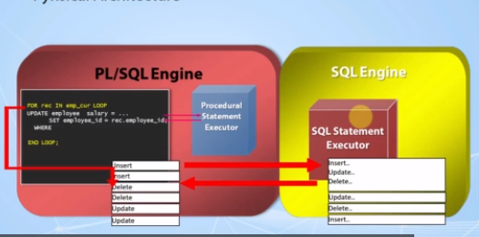

**Logical Architecture**

* **Cooperates with SQL Engine**
  + PL/SQL engine allows us to create, manage and execute SQL and PL/SQL codes and interact with the database
  + If you write an SQL code inside your PL/SQL codes, it will call the SQL engine and have this operation done with SQL engine. Then the result is sent back to the PL/SQL engine. This operation is called as context switches .One engine to another, and the opposite is valid.
* **Enables SubPrograms**
* **Dynamic Queries**
* **Case Insensitivity**
* **Optimizer**
* **Enables Object-Oriented Programming**
* **Web development**

**Lecture 5:What is Pluggable Databases?**

Pluggable database =Multitenant Architecture

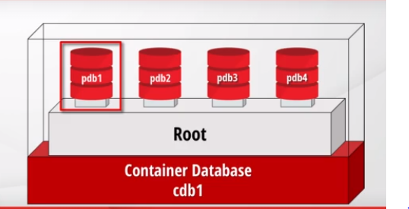

* Container databases does not have it’s objects, tables, etc. CDB store only metadata such as configuration files, etc.
* Pluggable databases have it’s own objects, tables, etc.
* In earlier versions of database, each database should be installed on a separate server .But in companies ,there are very small databases used for only some specific jobs. So there is no reason to dedicate another server for such a small database. Besides, each server is a lot of work for the DBAs.To make that easier,oracle updated its architecture now,there are pluggable databases in one container database.

**Lecture 6:The Sample(HR) schema used in this Course**

**What is Schema ?**

* Schemas are the collections of objects for each user in oracle database.

**What is HR Schema?**

* Abbreviation of Human Resources. A Schema that can practice on it.
* A schema can have objects like;
* Tables
* Views
* Triggers
* Constraints

**Lecture 8 : About the Database Installation**

**There are two ways to install database:**

**1.Using virtual box**

**2.using install directly database in a laptop**

**Lecture 9 : The Ways to Get a Database**

We offer 3 options to work with a database

1.Virtual Machine

2.Local Installation

3.Oracle Live SQL

**1.Virtual Machine🡪** To go with this option,we need to install VMware software

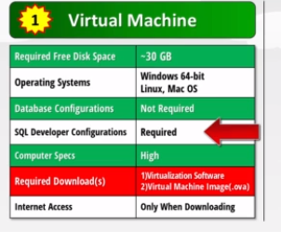

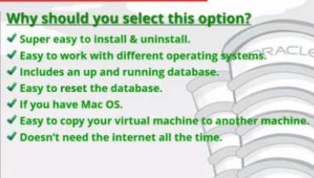

**2.Local Installation**

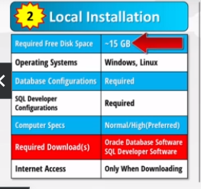

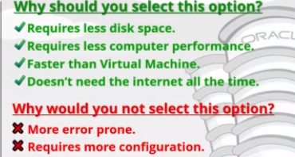

**3.Using Oracle Live SQL**

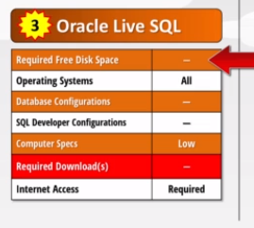

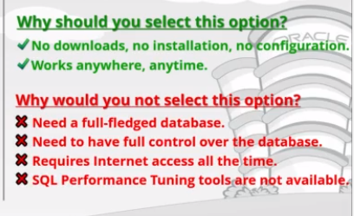

**Lecture 10 : Installing VMware and Virtual box on Windows**

**To download the VMware ,type the download vmware in a browser**

[**https://www.vmware.com/in/products/workstation-player/workstation-player-evaluation.html**](https://www.vmware.com/in/products/workstation-player/workstation-player-evaluation.html)

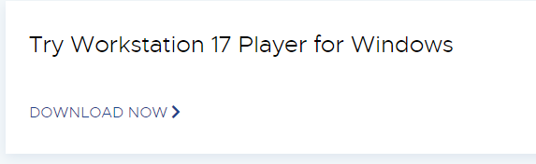

**Click the downloaded file-🡪click finish but at the end**

**To download the Virtualbox,type the download oracle Virtualbox in a browser**

[**https://www.virtualbox.org/wiki/Downloads**](https://www.virtualbox.org/wiki/Downloads)

**Click the downloaded file-🡪click finish but at the end**

**Lecture 11 : How to Install the Virtual Box on Mac OS X?**

**Option 1: How to Install the Virtual Box on Mac OS X?**

Hi Dear Friends,

You can **skip**this lesson in case you have another operating system different than the **Mac OS X**.

#### ****1) Download the two software packages that you need:****

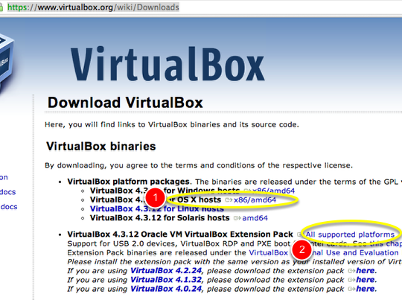

1. Visit <http://www.virtualbox.org/wiki/Downloads>
2. Click on the link for OS X hosts.
3. This will bring up a download window with a filename similar to “VirtualBox-4.3.12-93733-OSX.dmg”.
4. Save the file someplace where you will be able to find it later.
5. The file is fairly small; only about 120MB on my computer.
6. Next, click on the “All supported platforms” link next to  “VirtualBox 4.3.12 Oracle VM VirtualBox Extension Pack” and save that file to the same location.

#### ****2) Confirm that you have the two packages that you need:****

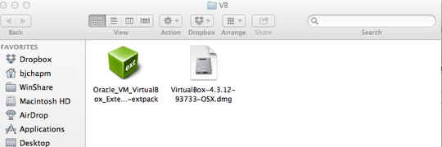

Once you are done, check-in the Finder and confirm that you have the two packages that you need. On my Mac, the display looks something like this. Of course, yours may look somewhat different depending on the way you have set Finder to display files.

#### ****3) Mount the VirtualBox disk image to start the installation process****

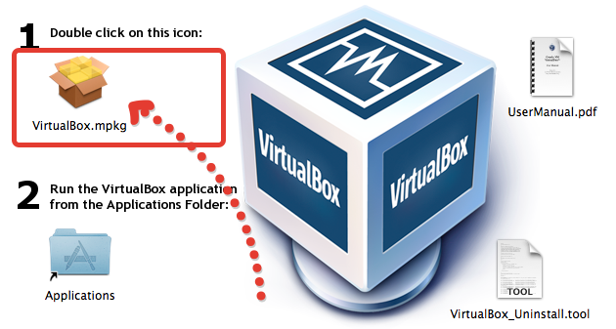

#### ****4) Install the VirtualBox program****

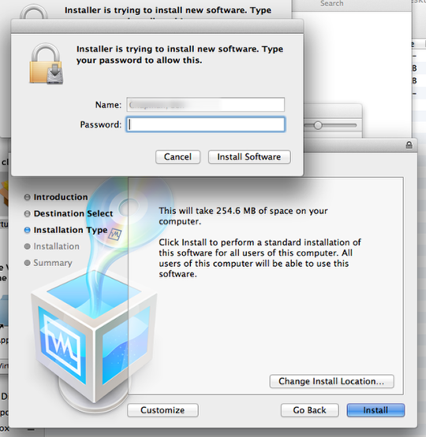

1. Double-click on the VirtualBox.pkg file to launch the actual installation.
2. Click Continue as prompted and then click “Install.” You will probably be prompted for your OSX administrative account password to enable the installation to proceed.
3. Enter the password to continue.
4. Click on “Install Software.”
5. On my MacBook Air, this took about one minute and I received a message saying that “The installation was successful.”
6. Click Close.

#### ✮****Congrats!****✮ ****Start the application and install the extension pack****✮https://img-c.udemycdn.com/redactor/raw/2017-12-03_13-46-24-cf7e6597e72ddae0f897ffdcefd298c2.png

1. Switch into your Applications folder in the Finder.
2. Locate VirtualBox and double-click on the application.
3. It should launch and, with luck, you won’t see any errors.
4. The very first thing you need to do is to install the extension pack. Without the extension, you won’t have access to a number of useful features.
5. Click on VirtualBox > Preferences (or use the keyboard shortcut Cmd-,). Then click on “**Extensions”** in the top bar (#1 above).
6. Now, click on the blue square with the yellow dropdown symbol (#2 above)
7. This will bring up a file navigator – navigate to the location where you saved the extension pack and select it.
8. You’ll see a warning message. Read it and click **Install**.
9. You’ll have to read (or at least scroll through) a long Oracle license agreement before you can click OK or similar.
10. You’ll be prompted for your local administrator password. Enter it and click to proceed.
11. The installation will complete.
12. You should be able to click “**OK**” to leave the VirtualBox preferences screen.

**Lecture 13 : Option 1 Downloading Virtual Machine**

Type download oracle pre-bulit virtual machine in a browser

https://www.oracle.com/downloads/developer-vm/community-downloads.html

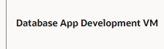

**Lecture 14 : Configuring the VMware Virtualization Software**

**Go to the play option🡪File->open virtual machine->choose the file(ova file)-🡪Name for new Virtual machine(Oracle Development Environment)🡪**

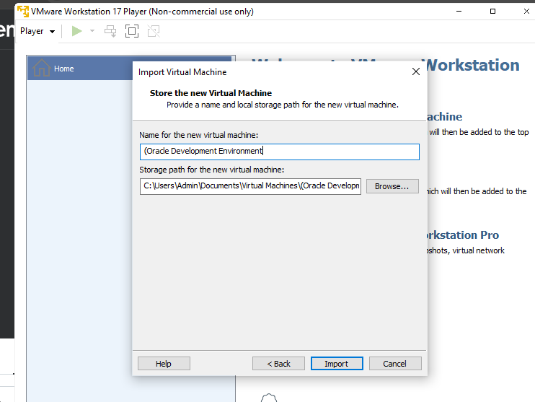

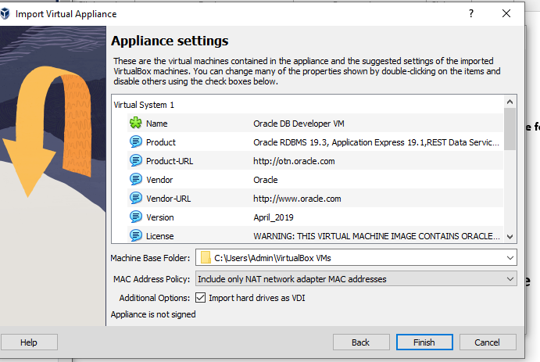

**Make hardware changes so that virtual machine runs properly.**

**Right click on virtual machine-🡪choose setting option-🡪choose system option (to increase the memory size)-🡪**

**Go to the processor option-🡪make it maximum-🡪**

**Click on the below button to start the machine**

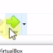

**Lecture 16 : Configuring SQL Developer Inside the Virtual Machine**

**Double click on SQL developer in a virtual machine**

**Right click on system connection🡪choose properties option**

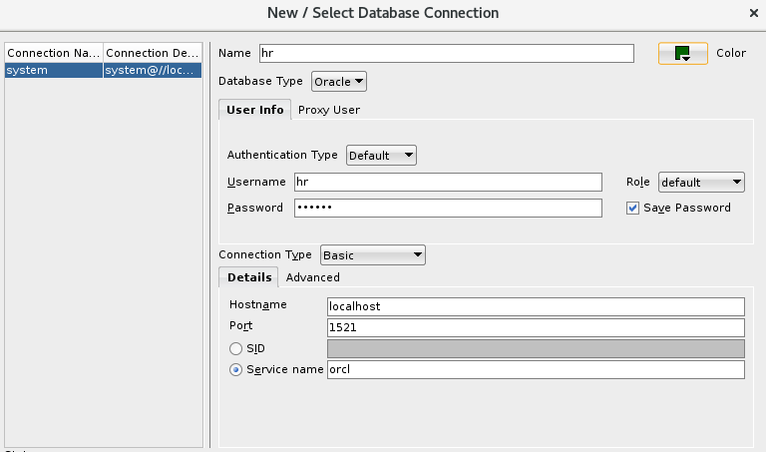

**Click on test button**

**Sys🡪user will be created for high level system administration**

**Lecture 15 : Configuring the VirtualBox Virtualization Software**

**Choose the import option-🡪**

**Lecture 18 : Downloading and Installing Oracle Database**

**Type the Download oracle database in a chrome**

[**https://www.oracle.com/in/database/technologies/oracle-database-software-downloads.html**](https://www.oracle.com/in/database/technologies/oracle-database-software-downloads.html)

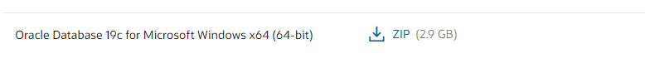

**Extract the zip file**

**Create one folder with name OracleApp and copy that extracted folder into this folder.**

**Go to WINDOWS_X64_19300 folder-🡪double click on setup.exe file**

**In Configuration option -🡪choose the create and Configure a single instance option**

**In System option -🡪Desktop**

**In Oracle Home server option -🡪Use windows built in account-🡪Click yes**

**In Typical Installation option -🡪 Global database name(orcl)🡪Pluggable database**

**name(orclpdb)**

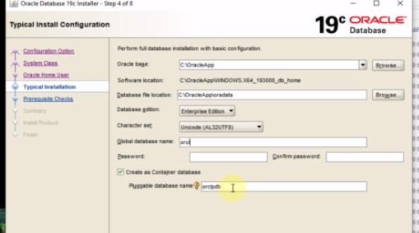

**Password – 123**

**Next-🡪yes🡪**

**Lecture 19 :Unlocking the HR Schema**

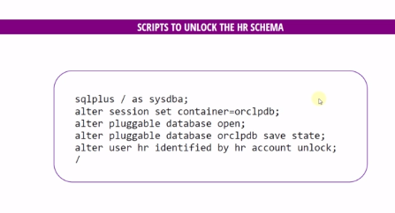

**Open the cmd and run the above code.**

**Sqlplus is used to connect with the oracle database.**

**Lecture 23 : Using Oracle Live SQL**

**Search Oracle LIVE SQL in a browser**

[**https://livesql.oracle.com/apex/f?p=590:1000 (Go**](https://livesql.oracle.com/apex/f?p=590:1000%20(Go) **to this link) and click on start coding button**

**username –** [**shalineemotarwar@gmail.com**](mailto:shalineemotarwar@gmail.com)

**password – Sanket@14**

**Lecture 24 :About Oracle Live SQL Restrictions**

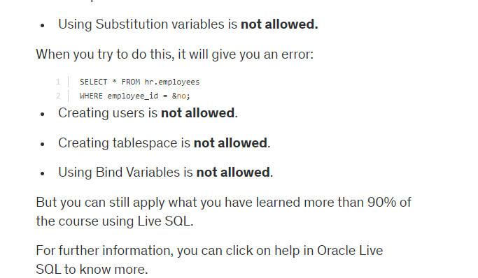

**Lecture 25 :Anonymous Blocks**

1. **Blocks--🡪**

* In PL/SQL programming,you need to write all your code in blocks.
* Blocks are the executable code groups that are inside the “begin end”key words.
* Declare section(optional)
* Begin Section is mandatory
* Exception section is optional
* END;(mandatory)

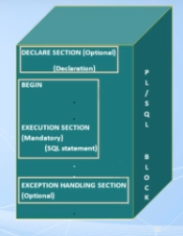

**Create HR schema in SQL developer**

There are 3 types of block

* Anonymous Blocks
* Procedures---🡪it doesn’t return a value
* Functions--🡪it must return a value

**Lecture 26 :PL/SQL Outputs**

1. **Not an output language**
2. **SET SERVEROUTPUT ON**
3. **DBMS_OUTPUT -🡪** It is an oracle’s prebuilt package that can do some output operations

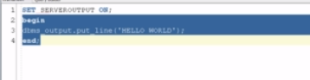

SET Serveroutput on is needed in Oracle SQL developer software

**4.Nested Blocks**

<https://livesql.oracle.com/apex/livesql/s/1e478gzeym455pcj7rbfupg7>

**Lecture 27: What are variables and Why to use them?**

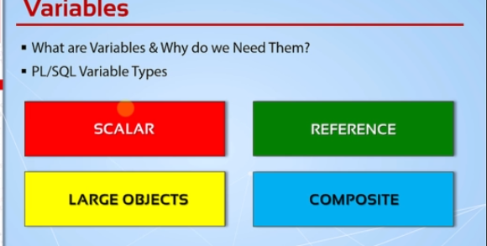

**1.Reference Datatype--🡪This datatypes hold value which point to a storage location**

**2.Large Objects---🡪This are also pointers to other data items that are stored outside of table such as images,files,etc.**

**3.Composite-🡪collections(this datatype can hold more than one value in it).**

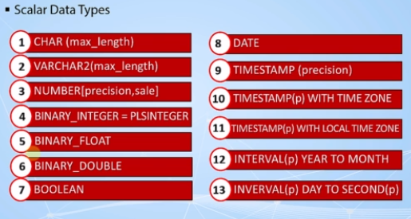

**Lecture 28 : Naming Rules and Naming Conventions**

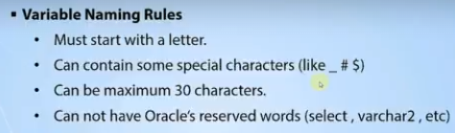

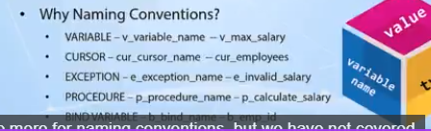

**Lecture 29:Declaring and Initializing & Using Variables Part1**

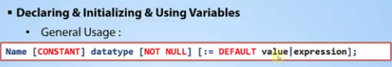

<https://livesql.oracle.com/apex/livesql/s/1e52pzqo7nqemn7o1nq3lkkq>

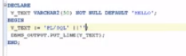

**Lecture 30 : Declaring and Initializing & Using Variables Part2**

Declare

V_number PLS_INTEGER(10,5) NOT NULL :=50.42

BEGIN

DBMS_OUTPUT.put_line(V_number || ‘shalu’);

END;

**Lecture 31 : Declaring and Initializing & Using Variables (Code Samples)**

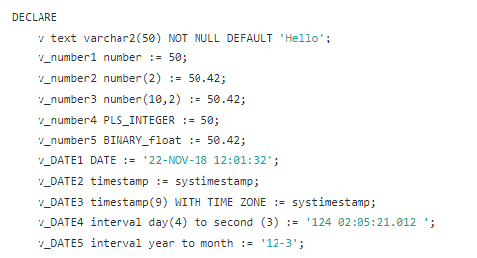

**Lecture 32 : Using % Attribute**

The %TYPE attribute is used to declare variables according to the already declared variable or database column. It is used when you are declaring an individual variable, not a record. The data type and precision of the variable declared using %TYPE attribute is the same as that of the column that is referred from a given table. This is particularly useful when declaring variables that will hold database values. When using the %TYPE keyword, the name of the columns and the table to which the variable will correspond must be known to the user. These are then prefixed with the variable name. If some previously declared variable is referred then prefix that variable name to the %TYPE attribute.

**Syntax:** <var_name> <tab_name>.<column_name>%TYPE;

**Example:**

declare

v_type emp.name%type;

begin

v_type:='shalu';

dbms_output.put_line(v_type) ;

end;

<https://livesql.oracle.com/apex/livesql/s/1iiu4xf1o8ew8qq22vziczi6>

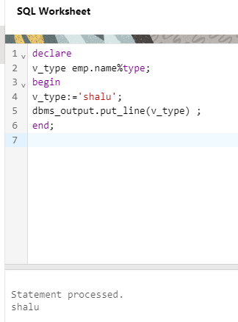

**Lecture 33 : Using %Type Attribute (Code Samples)**

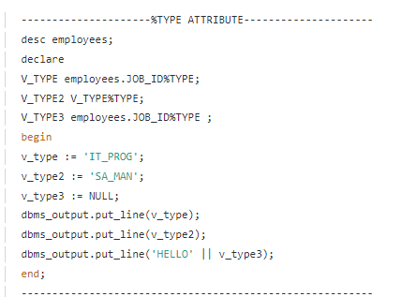

**Lecture 34 :PL/SQL Delimiters and Commenting Your Code**

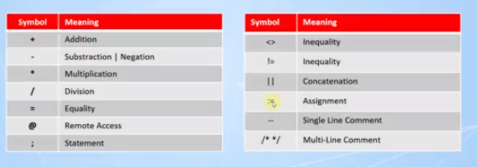

**---(single line comment)**

**/* */ -🡪Multi line comment**

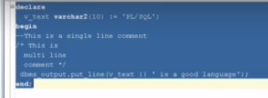

**Lecture 35 :PL/SQL Delimiters and Commenting Your Code(Code Samples)**

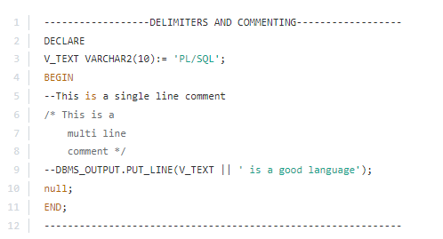

**Lecture 36 :PL/SQL Variable Scope**

1. begin <<outer>>
2. DECLARE
3. --v_outer VARCHAR2(50) := 'Outer Variable!';
4. v_text VARCHAR2(20) := 'Out-text';
5. BEGIN
6. DECLARE
7. v_text VARCHAR2(20) := 'In-text';
8. v_inner VARCHAR2(30) := 'Inner Variable';
9. BEGIN
10. --dbms_output.put_line('inside -> ' || v_outer);
11. --dbms_output.put_line('inside -> ' || v_inner);
12. dbms_output.put_line('inner -> ' || v_text);
13. dbms_output.put_line('outer -> ' || outer.v_text);
14. END;
15. --dbms_output.put_line('inside -> ' || v_inner);
16. --dbms_output.put_line(v_outer);
17. dbms_output.put_line(v_text);
18. END;
19. END outer;

<https://livesql.oracle.com/apex/livesql/s/1izv1v0iomtyb7muw5gsevim>

**Lecture 37 :PL/SQL Variable Scope(Code Samples)**

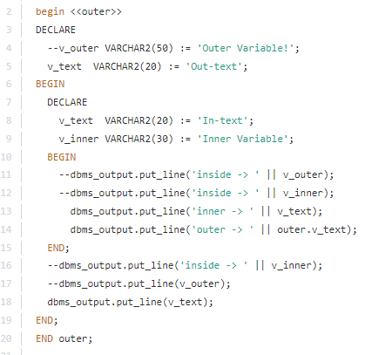

**Lecture 38: Using Bind Variables**

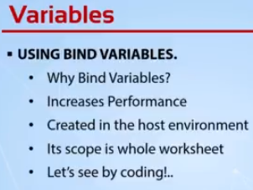

**-🡪We can access bind variables from another block where bind variable is not declared.**

**-🡪We need to call the bind variables explicitly,it’s automatically called during run and it will print the value;**

**-🡪We cannot directly assign the values to a bind variable**

**Syntax for declaration of bind variable:**

Variable var_sql number;////var_sql is the name of bind variable

**Syntax for definition of bind variable:**

var_sql=40;

1. set serveroutput on;
2. set autoprint on;
3. /
4. variable var_text varchar2(30);
5. /
6. variable var_number NUMBER;
7. /
8. variable var_date DATE;
9. /
10. declare
11. v_text varchar2(30);
12. begin
13. :var_text := 'Hello SQL';
14. :var_number := 20;
15. v_text := :var_text;
16. --dbms_output.put_line(v_text);
17. --dbms_output.put_line(:var_text);
18. end;
19. /
20. print var_text;
21. /
22. variable var_sql number;
23. /
24. begin
25. :var_sql := 100;
26. end;
27. /
28. select * from employees where employee_id = :var_sql;
29. /*------------------------BIND VARIABLES--------------------------
30. NOTE: When you run a bind variable creation and SELECT statement
31. together, SQL Developer may return an error but when you execute
32. them separately, there will be no problem.
33. **Lecture 39: Using Bind Variables (Code Samples)**

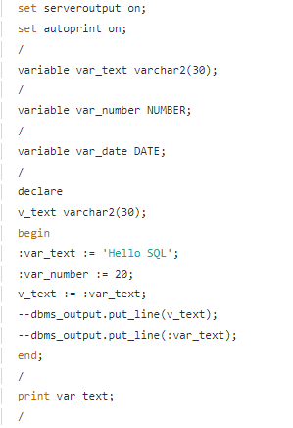

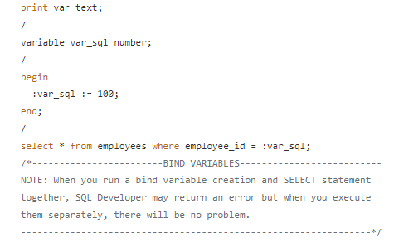

**Lecture 40: What Are Control Structures and If Statements**

**Lecture 41: What Are Control Structures and If Statements ( Code Samples)**

**Lecture 42:Case Expressions**

**Lecture 43:Case Expressions(Code Samples)**

/*************** The Complete PL/SQL Bootcamp ***************

* Author : Oracle Master Training *

* Course : The Complete Oracle PL/SQL Bootcamp *

* Lecture : CASE Expressions *

************************************************************/

/****************** Simple Case Expression ******************/

DECLARE

v_job_code VARCHAR2(10) := 'SA_MAN';

v_salary_increase NUMBER;

BEGIN

v_salary_increase := CASE v_job_code

WHEN 'SA_MAN' THEN 0.2

WHEN 'SA_REP' THEN 0.3

ELSE 0

END;

dbms_output.put_line('Your salary increase is : '|| v_salary_increase);

END;

/************************************************************/

/****************** Searched Case Expression ****************/

DECLARE

v_job_code VARCHAR2(10) := 'IT_PROG';

v_department VARCHAR2(10) := 'IT';

v_salary_increase NUMBER;

BEGIN

v_salary_increase:=CASE

WHEN v_job_code = 'SA_MAN' THEN 0.2

WHEN v_department = 'IT' AND v_job_code = 'IT_PROG' THEN 0.3

ELSE 0

END;

dbms_output.put_line('Your salary increase is : '|| v_salary_increase);

END;

/************************************************************/

/********************* CASE Statements **********************/

DECLARE

v_job_code VARCHAR2(10) := 'IT_PROG';

v_department VARCHAR2(10) := 'IT';

v_salary_increase NUMBER;

BEGIN

CASE

WHEN v_job_code = 'SA_MAN' THEN

v_salary_increase := 0.2;

dbms_output.put_line('The salary increase for a Sales Manager is: '|| v_salary_increase);

WHEN v_department = 'IT' AND v_job_code = 'IT_PROG' THEN

v_salary_increase := 0.2;

dbms_output.put_line('The salary increase for a Sales Manager is: '|| v_salary_increase);

ELSE

v_salary_increase := 0;

dbms_output.put_line('The salary increase for this job code is: '|| v_salary_increase);

END CASE;

END;

/************************************************************/

**Lecture 44: What Are Basic Loops**

**Lecture 45: What Are Basic Loops (Code Samples)**

DECLARE

v_counter NUMBER(2) := 1;

BEGIN

LOOP

dbms_output.put_line('My counter is : '|| v_counter);

v_counter := v_counter + 1;

--IF v_counter = 10 THEN

-- dbms_output.put_line('Now I reached : '|| v_counter);

-- EXIT;

--END IF;

EXIT WHEN v_counter > 10;

END LOOP;

END;

**Lecture 46: While Loops** 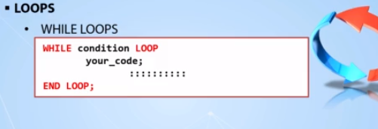

**Lecture 47: While Loops (Code Samples)**

DECLARE

v_counter NUMBER(2) := 1;

BEGIN

WHILE v_counter <= 10 LOOP

dbms_output.put_line('My counter is : '|| v_counter);

v_counter := v_counter + 1;

-- EXIT WHEN v_counter > 3;

END LOOP;

END;

**Lecture 48: For Loops**

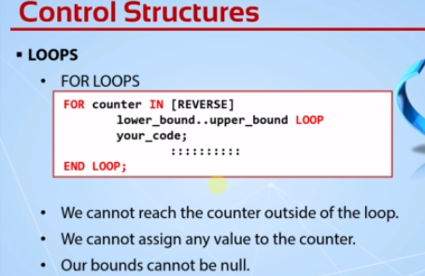

**Lecture 49: For Loops(Code Samples)**

BEGIN

FOR i IN REVERSE 1..3 LOOP

dbms_output.put_line('My counter is : ' || i);

END LOOP;

END;

**Lecture 50: Nested Loops & Loop Labeling**

**Lecture 51: Nested Loops & Loop Labeling(Code Samples)**

DECLARE

v_inner NUMBER := 1;

BEGIN

FOR v_outer IN 1..5 LOOP

dbms_output.put_line('My outer value is : ' || v_outer );

v_inner := 1;

LOOP

v_inner := v_inner+1;

dbms_output.put_line(' My inner value is : ' || v_inner );

EXIT WHEN v_inner * v_outer >= 15;

END LOOP;

END LOOP;

END;

/************************************************************/

/**************** Nested Loops with Labels ******************/

DECLARE

v_inner NUMBER := 1;

BEGIN

<<outer_loop>>

FOR v_outer IN 1..5 LOOP

dbms_output.put_line('My outer value is : ' || v_outer );

v_inner := 1;

<<inner_loop>>

LOOP

v_inner := v_inner+1;

dbms_output.put_line(' My inner value is : ' || v_inner );

EXIT outer_loop WHEN v_inner * v_outer >= 16;

EXIT WHEN v_inner * v_outer >= 15;

END LOOP inner_loop;

END LOOP outer_loop;

END;

/****************/

**Lecture 52: Continue Statement**

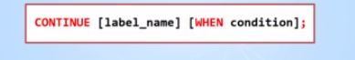

**Lecture 53: Continue Statement(Code Samples)**

DECLARE

v_inner NUMBER := 1;

BEGIN

FOR v_outer IN 1..10 LOOP

dbms_output.put_line('My outer value is : ' || v_outer );

v_inner := 1;

WHILE v_inner * v_outer < 15 LOOP

v_inner := v_inner + 1;

CONTINUE WHEN MOD(v_inner * v_outer,3) = 0;

dbms_output.put_line(' My inner value is : ' || v_inner );

END LOOP;

END LOOP;

END;

**Lecture 54: GOTO Statement**

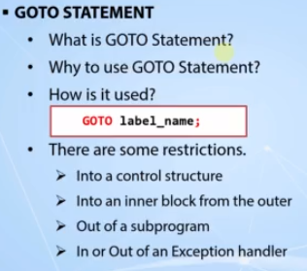

**Lecture 54: GOTO Statement(Code Samples)**

DECLARE

v_searched_number NUMBER := 22;

v_is_prime BOOLEAN := true;

BEGIN

FOR x IN 2..v_searched_number-1 LOOP

IF v_searched_number MOD x = 0 THEN

dbms_output.put_line(v_searched_number|| ' is not a prime number..');

v_is_prime := false;

GOTO end_point;

END IF;

END LOOP;

IF v_is_prime THEN

dbms_output.put_line(v_searched_number|| ' is a prime number..');

END IF;

<<end_point>>

dbms_output.put_line('Check complete..');

END;

/************************************************************/

DECLARE

v_searched_number NUMBER := 32457;

v_is_prime BOOLEAN := TRUE;

x NUMBER := 2;

BEGIN

<<start_point>>

IF v_searched_number MOD x = 0 THEN

dbms_output.put_line(v_searched_number|| ' is not a prime number..');

v_is_prime := FALSE;

GOTO end_point;

END IF;

x := x+1;

IF x = v_searched_number THEN

GOTO prime_point;

END IF;

GOTO start_point;

<<prime_point>>

IF v_is_prime THEN

dbms_output.put_line(v_searched_number || ' is a prime number..');

END IF;

<<end_point>>

dbms_output.put_line('Check complete..');

END;

/************************************************************/

**Lecture 56: Operating with Selected Database data**

Transactions ends with a commit,rollback or a system failure.

**How to use SQL in PL/SQL?**

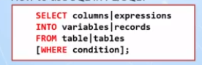

**Lecture 57: Operating with Selected Database data(Code Samples)**

/************************ Example 1 *************************/

DECLARE

v_name VARCHAR2(50);

v_salary employees.salary%type;

BEGIN

SELECT first_name ||' '|| last_name, salary

INTO v_name, v_salary

FROM employees

WHERE employee_id = 130;

dbms_output.put_line('The salary of '|| v_name || ' is : '|| v_salary);

END;

/************************ Example 2 *************************/

DECLARE

v_name VARCHAR2(50);

sysdates employees.hire_date%type;

BEGIN

SELECT first_name ||' '|| last_name, sysdates

INTO v_name, sysdates

FROM employees

WHERE employee_id = 130;

dbms_output.put_line('The salary of '|| v_name || ' is : '|| sysdates);

END;

/************************ Example 3 *************************/

DECLARE

v_name VARCHAR2(50);

v_sysdate employees.hire_date%type;

employee_id employees.employee_id%type := 130;

BEGIN

SELECT first_name ||' '|| last_name, sysdate

INTO v_name, v_sysdate

FROM employees

WHERE employee_id = employee_id;

dbms_output.put_line('The salary of '|| v_name || ' is : '|| v_sysdate );

END;

/************************ Example 4 *************************/

DECLARE

v_name VARCHAR2(50);

v_salary employees.salary%type;

v_employee_id employees.employee_id%type := 130;

BEGIN

SELECT first_name ||' '|| last_name, salary

INTO v_name, v_salary

FROM employees

WHERE employee_id = v_employee_id;

dbms_output.put_line('The salary of '|| v_name || ' is : '|| v_salary );

END;

**Lecture 58: DML Operations in PL/SQL**

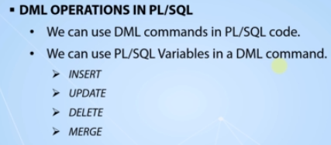

**Lecture 59: DML Operations in PL/SQL(Code Samples)**

**CREATE TABLE employees_copy**

AS SELECT * FROM employees;

DECLARE

v_employee_id PLS_INTEGER := 0;

v_salary_increase NUMBER := 400;

BEGIN

FOR i IN 217..226 LOOP

-- INSERT INTO employees_copy

-- (employee_id, first_name, last_name, email, hire_date, job_id, salary)

-- VALUES

-- (i, 'employee#'||i,'temp_emp','abc@xmail.com',sysdate,'IT_PROG',1000);

-- UPDATE employees_copy

-- SET salary = salary + v_salary_increase

-- WHERE employee_id = i;

DELETE FROM employees_copy

WHERE employee_id = i;

END LOOP;

END;

**Lecture 60: Using Sequences in PL/SQL**

CREATE SEQUENCE employee_id_seq

START WITH 207

INCREMENT BY 1;

/************************ Example 1 *************************/

BEGIN

FOR i IN 1..10 LOOP

INSERT INTO employees_copy

(employee_id,first_name,last_name,email,hire_date,job_id,salary)

VALUES

(employee_id_seq.nextval,'employee#'||employee_id_seq.nextval,'temp_emp','abc@xmail.com',sysdate,'IT_PROG',1000);

END LOOP;

END;

/************************ Example 2 *************************/

DECLARE

v_seq_num NUMBER;

BEGIN

SELECT employee_id_seq.nextval

INTO v_seq_num

FROM dual;

dbms_output.put_line(v_seq_num);

END;

/************************ Example 3 *************************/

DECLARE

v_seq_num NUMBER;

BEGIN

SELECT employee_id_seq.nextval

INTO v_seq_num

FROM employees_copy

WHERE rownum = 1;

dbms_output.put_line(v_seq_num);

END;

/************************ Example 4 *************************/

DECLARE

v_seq_num NUMBER;

BEGIN

v_seq_num := employee_id_seq.nextval;

dbms_output.put_line(v_seq_num);

END;

/************************ Example 5 *************************/

BEGIN

dbms_output.put_line(employee_id_seq.nextval);

END;

/************************ Example 6 *************************/

BEGIN

dbms_output.put_line(employee_id_seq.currval);

END;

**Lecture 62: Extra – Enabling Server Outputs by Default**

**Lecture 63: Simple Data Types vs Composite Data Types**

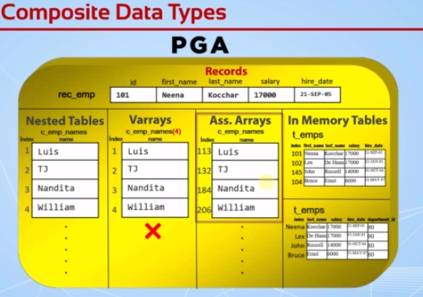

**Nested Tables-🡪**We can add indexes dynamically according to the need.We don’t need to declare it’s size.and the indexes starts from 1.

**Varrays🡪** We can’ add indexes dynamically according to the need.We need to declare it’s size.and the indexes starts from 1

**Ass.Arrays🡪** We can add indexes dynamically according to the need.We don’t need to declare it’s size.and the indexes starts from any number and indexes can be a negative number also.

**Collections-🡪** Nested Tables,Varrays,Ass.Arrays,In Memory Tables

**Lecture 64:PL/SQL Records – Part1**

**We can store a whole row in a record.All the variables stored in a record are related to each other.We can add one record inside a another record.By default all the variables in a record are null.**

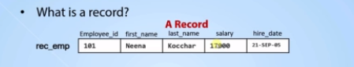

**We get all of the column’s types of a row into one record in one step. Using %rowtype**

**Syntax:**

**Way 1: record_name table_name%rowtype;**

**Example:**

DECLARE

r_emp employees%rowtype;

BEGIN

SELECT * INTO r_emp

FROM employees

WHERE employee_id = '101';

--r_emp.salary := 2000;

dbms_output.put_line(r_emp.first_name || ' ' || r_emp.last_name || ' earns '|| r_emp.salary || ' and hired at : ' || r_emp.hire_date);

end;

**Way 2:**

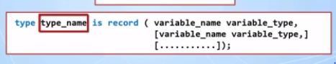

**Example:**

DECLARE

--r_emp employees%rowtype;

type t_emp IS RECORD (first_name VARCHAR2(50), last_name employees.last_name%TYPE, salary employees.salary%TYPE, hire_date DATE);

r_emp t_emp;

BEGIN

SELECT first_name,last_name,salary,hire_date INTO r_emp

FROM employees WHERE employee_id = '101';

dbms_output.put_line(r_emp.first_name || ' ' || r_emp.last_name || ' earns ' || r_emp.salary || ' and hired at : ' || r_emp.hire_date);

END;



Every Record can get only one level.

**Lecture 65:PL/SQL Records – Part2**

DECLARE

TYPE t_edu is RECORD(primary_school VARCHAR2(100),

high_school VARCHAR2(100),

university VARCHAR2(100),

uni_graduate_date DATE

);

TYPE t_emp IS RECORD(first_name VARCHAR2(50),

last_name employees.last_name%type,

salary employees.salary%type NOT NULL DEFAULT 1000,

hire_date DATE,

dept_id employees.department_id%type,

department departments%rowtype,

education t_edu

);

r_emp t_emp;

BEGIN

SELECT first_name, last_name, salary, hire_date, department_id

INTO r_emp.first_name, r_emp.last_name, r_emp.salary, r_emp.hire_date, r_emp.dept_id

FROM employees where employee_id = '146';

SELECT *

INTO r_emp.department

FROM departments

WHERE department_id = r_emp.dept_id;

r_emp.education.high_school := 'Beverly Hills';

r_emp.education.university := 'Oxford';

r_emp.education.uni_graduate_date := '01-JAN-13';

dbms_output.put_line(r_emp.first_name || ' ' ||

r_emp.last_name || ' earns ' ||

r_emp.salary || ' and hired at : ' ||

r_emp.hire_date);

dbms_output.put_line('She graduated from ' ||

r_emp.education.university ||

' at ' ||

r_emp.education.uni_graduate_date);

dbms_output.put_line('Her Department Name is : '|| r_emp.department.department_name);

END;

/************************************************************/

**Lecture 67 : Easy DML With Records**

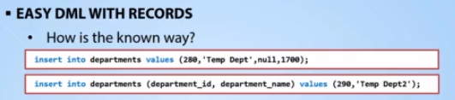

CREATE TABLE retired_employees

AS SELECT * FROM employees WHERE 1=2;

SELECT * FROM retired_employees;

/

DECLARE

r_emp employees%rowtype;

BEGIN

SELECT * INTO r_emp FROM employees WHERE employee_id = 104;

r_emp.salary := 0;

r_emp.commission_pct := 0;

INSERT INTO retired_employees VALUES r_emp;

END;

/************************************************************/

DECLARE

r_emp employees%rowtype;

BEGIN

SELECT * INTO r_emp FROM employees WHERE employee_id = 104;

r_emp.salary := 10;

r_emp.commission_pct := 0;

--insert into retired_employees values r_emp;

UPDATE retired_employees SET row = r_emp WHERE employee_id = 104;

end;

/

DELETE FROM retired_employees;

/************************************************************/

**Lecture 69: What Are Collections?**

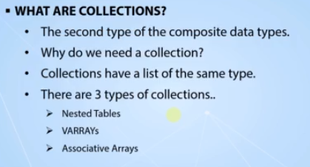

**Lecture 70:Varrays & Collection Methods**

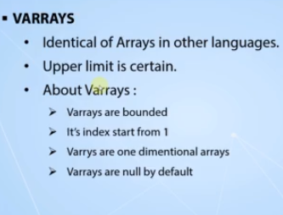

**Once we declare the elements in a varray,we can’t delete after that.**

**Count()-🡪**It will checks the how many elements are there in a collection

**Example:varray_name.count();**

**First()-🡪**it will give the first element from the collection

**Last()🡪**it will give the last element from the collection

**Limit()-🡪**It gives the maximum size of the collection

**Lecture 71:Varrays (Code Samples)**

DECLARE

TYPE e_list IS VARRAY(5) OF VARCHAR2(50);

employees e_list;

BEGIN

employees := e_list('Alex','Bruce','John','Bob','Richard');

FOR i IN 1..5 LOOP

dbms_output.put_line(employees(i));

END LOOP;

END;

/************** Limit Exceeding Error Example ***************/

DECLARE

TYPE e_list IS VARRAY(4) OF VARCHAR2(50);

employees e_list;

BEGIN

employees := e_list('Alex','Bruce','John','Bob','Richard');

FOR i IN 1..5 LOOP

dbms_output.put_line(employees(i));

END LOOP;

END;

/*********** Subscript Beyond Count Error Example ***********/

DECLARE

TYPE e_list IS VARRAY(5) OF VARCHAR2(50);

employees e_list;

BEGIN

employees := e_list('Alex','Bruce','John','Bob');

FOR i IN 1..5 LOOP

dbms_output.put_line(employees(i));

end loop;

END;

/**************** A Working count() Example *****************/

DECLARE

TYPE e_list IS VARRAY(5) OF VARCHAR2(50);

employees e_list;

BEGIN

employees := e_list('Alex','Bruce','John','Bob');

for i IN 1..employees.count() LOOP

dbms_output.put_line(employees(i));

END LOOP;

END;

/************ A Working first() last() Example **************/

DECLARE

TYPE e_list IS VARRAY(5) OF VARCHAR2(50);

employees e_list;

BEGIN

employees := e_list('Alex','Bruce','John','Bob');

FOR i IN employees.first()..employees.last() LOOP

dbms_output.put_line(employees(i));

END LOOP;

END;

/*************** A Working exists() Example *****************/

DECLARE

TYPE e_list IS VARRAY(5) OF VARCHAR2(50);

employees e_list;

BEGIN

employees := e_list('Alex','Bruce','John','Bob');

FOR i IN 1..5 LOOP

IF employees.exists(i) THEN

dbms_output.put_line(employees(i));

END IF;

END LOOP;

END;

/**************** A Working limit() Example *****************/

DECLARE

TYPE e_list IS VARRAY(5) OF VARCHAR2(50);

employees e_list;

BEGIN

employees := e_list('Alex','Bruce','John','Bob');

dbms_output.put_line(employees.limit());

END;

/****** A Create-Declare at the Same Time Error Example *****/

DECLARE

TYPE e_list IS VARRAY(5) OF VARCHAR2(50);

employees e_list('Alex','Bruce','John','Bob');

BEGIN

--employees := e_list('Alex','Bruce','John','Bob');

FOR i IN 1..5 LOOP

IF employees.exists(i) THEN

dbms_output.put_line(employees(i));

END IF;

END LOOP;

END;

/************** A Post Insert Varray Example ****************/

DECLARE

TYPE e_list IS VARRAY(15) OF VARCHAR2(50);

employees e_list := e_list();

idx NUMBER := 1;

BEGIN

FOR i IN 100..110 LOOP

employees.extend;

SELECT first_name

INTO employees(idx)

FROM employees

WHERE employee_id = i;

idx := idx + 1;

END LOOP;

FOR x IN 1..employees.count() LOOP

dbms_output.put_line(employees(x));

END LOOP;

END;

/******* An Example for the Schema-Level Varray Types *******/

CREATE TYPE e_list IS VARRAY(15) OF VARCHAR2(50);

/

CREATE OR REPLACE TYPE e_list AS VARRAY(20) OF VARCHAR2(100);

/

DECLARE

employees e_list := e_list();

idx NUMBER := 1;

BEGIN

FOR i IN 100..110 LOOP

employees.extend;

SELECT first_name

INTO employees(idx)

FROM employees

WHERE employee_id = i;

idx := idx + 1;

END LOOP;

FOR x IN 1..employees.count() LOOP

dbms_output.put_line(employees(x));

END LOOP;

END;

/

DROP TYPE E_LIST;

**Lecture 72 : Nested Tables**

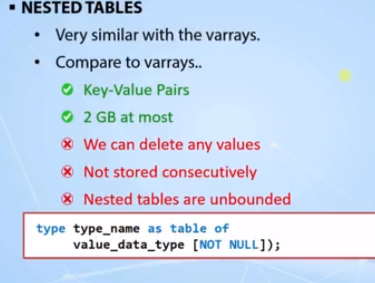

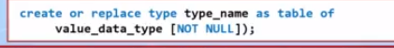

**Lecture 72 : Nested Tables(Code Samples)**

DECLARE

TYPE e_list IS TABLE OF VARCHAR2(50);

emps e_list;

BEGIN

emps := e_list('Alex','Bruce','John');

FOR i IN 1..emps.count() LOOP

dbms_output.put_line(emps(i));

END LOOP;

END;

/************************************************************

Adding a New Value to a Nested Table After the Initialization

*************************************************************/

DECLARE

TYPE e_list IS TABLE OF VARCHAR2(50);

emps e_list;

BEGIN

emps := e_list('Alex','Bruce','John');

emps.extend;

emps(4) := 'Bob';

FOR i IN 1..emps.count() LOOP

dbms_output.put_line(emps(i));

END LOOP;

END;

/*************** Adding Values From a Table *****************/

DECLARE

TYPE e_list IS TABLE OF employees.first_name%type;

emps e_list := e_list();

idx PLS_INTEGER:= 1;

BEGIN

FOR x IN 100 .. 110 LOOP

emps.extend;

SELECT first_name INTO emps(idx)

FROM employees

WHERE employee_id = x;

idx := idx + 1;

END LOOP;

FOR i IN 1..emps.count() LOOP

dbms_output.put_line(emps(i));

END LOOP;

END;

/********************* Delete Example ***********************/

DECLARE

TYPE e_list IS TABLE OF employees.first_name%type;

emps e_list := e_list();

idx PLS_INTEGER := 1;

BEGIN

FOR x IN 100 .. 110 LOOP

emps.extend;

SELECT first_name INTO emps(idx)

FROM employees

WHERE employee_id = x;

idx := idx + 1;

END LOOP;

emps.delete(3);

FOR i IN 1..emps.count() LOOP

IF emps.exists(i) THEN

dbms_output.put_line(emps(i));

END IF;

END LOOP;

END;

**Lecture 74: PL/SQL Associative Arrays (Part1)**

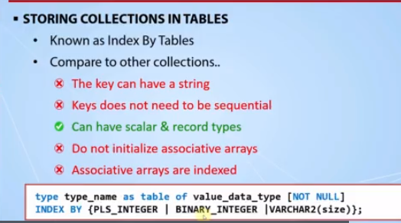

/********************* The First Example ********************/

DECLARE

TYPE e_list IS TABLE OF employees.first_name%TYPE INDEX BY PLS_INTEGER;

emps e_list;

BEGIN

FOR x IN 100 .. 110 LOOP

SELECT first_name

INTO emps(x)

FROM employees

WHERE employee_id = x ;

END LOOP;

FOR i IN emps.first()..emps.last() LOOP

dbms_output.put_line(emps(i));

END LOOP;

END;

/********* Error Example for the SELECT INTO Clause *********/

DECLARE

TYPE e_list IS TABLE OF employees.first_name%TYPE INDEX BY PLS_INTEGER;

emps e_list;

BEGIN

FOR x IN 100 .. 110 LOOP

SELECT first_name

INTO emps(x)

FROM employees

WHERE employee_id = x

AND department_id = 60;

END LOOP;

FOR i IN emps.first()..emps.last() LOOP

dbms_output.put_line(i);

END LOOP;

END;

/******* Error Example about Reaching an Empty Index ********/

DECLARE

TYPE e_list IS TABLE OF employees.first_name%TYPE INDEX BY PLS_INTEGER;

emps e_list;

BEGIN

emps(100) := 'Bob';

emps(120) := 'Sue';

FOR i IN emps.first()..emps.last() LOOP

dbms_output.put_line(emps(i));

END LOOP;

END;

/*************************************************************

An Example of Iterating in Associative Arrays with WHILE LOOPs

*************************************************************/

DECLARE

TYPE e_list IS TABLE OF employees.first_name%TYPE INDEX BY PLS_INTEGER;

emps e_list;

idx PLS_INTEGER;

BEGIN

emps(100) := 'Bob';

emps(120) := 'Sue';

idx := emps.first;

WHILE idx IS NOT NULL LOOP

dbms_output.put_line(emps(idx));

idx := emps.next(idx);

END LOOP;

END;

/*************************************************************

An Example of Using String-based Indexes with Associative Arrays

*************************************************************/

DECLARE

TYPE e_list IS TABLE OF employees.first_name%TYPE INDEX BY employees.email%type;

emps e_list;

idx employees.email%TYPE;

v_email employees.email%TYPE;

v_first_name employees.first_name%TYPE;

BEGIN

FOR x IN 100 .. 110 LOOP

SELECT first_name, email

INTO v_first_name, v_email

FROM employees

WHERE employee_id = x;

emps(v_email) := v_first_name;

END LOOP;

idx := emps.first;

WHILE idx IS NOT NULL LOOP

dbms_output.put_line('The email of '|| emps(idx) ||' is : '|| idx);

idx := emps.next(idx);

END LOOP;

END;

**Lecture 75: PL/SQL Associative Arrays (Part2)**

/*** An Example of Using Associative Arrays with Records ****/

DECLARE

TYPE e_list IS TABLE OF employees%rowtype INDEX BY employees.email%TYPE;

emps e_list;

idx employees.email%type;

BEGIN

FOR x IN 100 .. 110 LOOP

SELECT *

INTO emps(x)

FROM employees

WHERE employee_id = x;

END LOOP;

idx := emps.first;

WHILE idx IS NOT NULL LOOP

dbms_output.put_line('The email of ' ||

emps(idx).first_name || ' ' ||

emps(idx).last_name || ' is : '|| emps(idx).email);

idx := emps.next(idx);

END LOOP;

END;

/* An Example of Using Associative Arrays with Record Types */

DECLARE

TYPE e_type IS RECORD (first_name employees.first_name%TYPE,

last_name employees.last_name%TYPE,

email employees.email%TYPE);

TYPE e_list IS TABLE OF e_type INDEX BY employees.email%TYPE;

emps e_list;

idx employees.email%type;

BEGIN

FOR x IN 100 .. 110 LOOP

SELECT first_name,last_name,email

INTO emps(x)

FROM employees

WHERE employee_id = x;

END LOOP;

idx := emps.first;

WHILE idx IS NOT NULL LOOP

dbms_output.put_line('The email of ' ||

emps(idx).first_name || ' ' ||

emps(idx).last_name || ' is : ' ||

emps(idx).email);

idx := emps.next(idx);

END LOOP;

END;

/**** An Example of Printing From the Last to the First *****/

DECLARE

TYPE e_type IS RECORD (first_name employees.first_name%TYPE,

last_name employees.last_name%TYPE,

email employees.email%TYPE);

TYPE e_list IS TABLE OF e_type INDEX BY employees.email%TYPE;

emps e_list;

idx employees.email%type;

BEGIN

FOR x IN 100 .. 110 LOOP

SELECT first_name,last_name, email

INTO emps(x)

FROM employees

WHERE employee_id = x;

END LOOP;

--emps.delete(100,104);

idx := emps.last;

WHILE idx IS NOT NULL LOOP

dbms_output.put_line('The email of ' ||

emps(idx).first_name || ' ' ||

emps(idx).last_name ||' is : ' ||

emps(idx).email);

idx := emps.prior(idx);

END LOOP;

END;

/***** An Example of Inserting with Associative Arrays ******/

CREATE TABLE employees_salary_history

AS SELECT * FROM employees WHERE 1=2;

ALTER TABLE employees_salary_history ADD insert_date DATE;

SELECT * FROM employees_salary_history;

/

DECLARE

TYPE e_list IS TABLE OF employees_salary_history%rowtype INDEX BY PLS_INTEGER;

emps e_list;

idx PLS_INTEGER;

BEGIN

FOR x IN 100 .. 110 LOOP

SELECT e.*,'01-JUN-20'

INTO emps(x)

FROM employees e

WHERE employee_id = x;

END LOOP;

idx := emps.first;

WHILE idx IS NOT NULL LOOP

emps(idx).salary := emps(idx).salary + emps(idx).salary*0.2;

INSERT INTO employees_salary_history VALUES emps(idx);

dbms_output.put_line('The employee ' || emps(idx).first_name ||

' is inserted to the history table');

idx := emps.next(idx);

END LOOP;

END;

/

DROP TABLE employees_salary_history;

**Lecture 77: Storing Collection in Tables – (Part 1)**

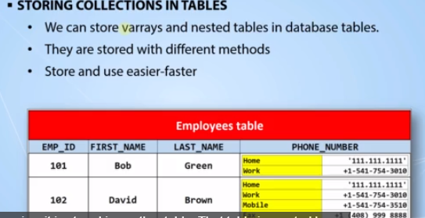

***************** Storing Varray Example *******************/

CREATE OR REPLACE TYPE t_phone_number AS OBJECT(p_type VARCHAR2(10),

p_number VARCHAR2(50)

);

/

CREATE OR REPLACE TYPE v_phone_numbers AS VARRAY(3) OF t_phone_number;

/

CREATE TABLE emps_with_phones(employee_id NUMBER,

first_name VARCHAR2(50),

last_name VARCHAR2(50),

phone_number v_phone_numbers);

/

SELECT * FROM emps_with_phones;

/

INSERT INTO emps_with_phones

VALUES(10,'Alex','Brown',v_phone_numbers(t_phone_number('HOME','111.111.1111'),

t_phone_number('WORK','222.222.2222'),

t_phone_number('MOBILE','333.333.3333'))

);

INSERT INTO emps_with_phones

VALUES(11,'Bob','Green',v_phone_numbers(t_phone_number('HOME','000.000.000'),

t_phone_number('WORK','444.444.4444'))

);

/

/*************** Querying the Varray Example ****************/

SELECT e.first_name,

last_name,

p.p_type,

p.p_number

FROM emps_with_phones e, table(e.phone_number) p;

/****** The Code For the Storing Nested Table Example *******/

CREATE OR REPLACE TYPE n_phone_numbers AS TABLE OF t_phone_number;

/

CREATE TABLE emps_with_phones2(employee_id NUMBER,

first_name VARCHAR2(50),

last_name VARCHAR2(50),

phone_number n_phone_numbers)

NESTED TABLE phone_number STORE AS phone_numbers_table;

/

SELECT * FROM emps_with_phones2;

/

INSERT INTO emps_with_phones2

VALUES(10,'Alex','Brown',n_phone_numbers(t_phone_number('HOME','111.111.1111'),

t_phone_number('WORK','222.222.2222'),

t_phone_number('MOBILE','333.333.3333'))

);

INSERT INTO emps_with_phones2 VALUES(11,'Bob','Green',n_phone_numbers(t_phone_number('HOME','000.000.000'),

t_phone_number('WORK','444.444.4444'))

);

/

SELECT e.first_name, last_name, p.p_type, p.p_number FROM emps_with_phones2 e, table(e.phone_number) p;

**Lecture 78: Storing Collection in Tables – (Part 2)**

/***************** New Insert and Update ********************/

INSERT INTO emps_with_phones2

VALUES(11,'Bob','Green',n_phone_numbers(t_phone_number('HOME','000.000.000'),

t_phone_number('WORK','444.444.4444'),

t_phone_number('WORK2','444.444.4444'),

t_phone_number('WORK3','444.444.4444'),

t_phone_number('WORK4','444.444.4444'),

t_phone_number('WORK5','444.444.4444'))

);

SELECT * FROM emps_with_phones2;

UPDATE emps_with_phones2

SET phone_number = n_phone_numbers(t_phone_number('HOME','000.000.000'),

t_phone_number('WORK','444.444.4444'),

t_phone_number('WORK2','444.444.4444'),

t_phone_number('WORK3','444.444.4444'),

t_phone_number('WORK4','444.444.4444'),

t_phone_number('WORK5','444.444.4444'))

WHERE employee_id = 11;

/**** Adding a New Value into a Nested Inside of a Table ****/

DECLARE

p_num n_phone_numbers;

BEGIN

SELECT phone_number

INTO p_num

FROM emps_with_phones2

WHERE employee_id = 10;

p_num.extend;

p_num(5) := t_phone_number('FAX','999.99.9999');

UPDATE emps_with_phones2

SET phone_number = p_num

WHERE employee_id = 10;

END;

/************************************************************/

**Lecture 80 : What are Cursors and Cursor Types in PL/SQL**

**PGA -🡪 Program Global Area**

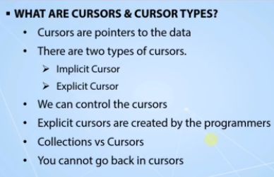

**The implicit cursors are created by the database server and managed automatically. Cursors are to handle the select queries. Fetching data from the memory.**

**The explicit cursors do not get all the result set into the memory directly.The server arranges that based on the result set and memory situation.**

**Lecture 81 : Using Explicit Cursors**

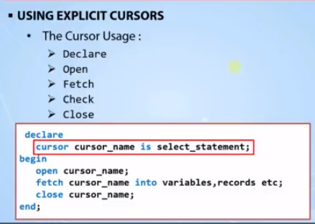

**declare**

**cursor c_emps is select first_name,last_name from employees;**

**v_first_name employees.first_name%type;**

**v_last_name employees.last_name%type;**

**begin**

**open c_emps;**

**fetch c_emps into v_first_name,v_last_name;**

**fetch c_emps into v_first_name,v_last_name;**

**fetch c_emps into v_first_name,v_last_name;**

**dbms_output.put_line(v_first_name|| ' ' || v_last_name);**

**fetch c_emps into v_first_name,v_last_name;**

**dbms_output.put_line(v_first_name|| ' ' || v_last_name);**

**close c_emps;**

**end;**

**--------------- cursor with join example**

**declare**

**cursor c_emps is select first_name,last_name, department_name from employees**

**join departments using (department_id)**

**where department_id between 30 and 60;**

**v_first_name employees.first_name%type;**

**v_last_name employees.last_name%type;**

**v_department_name departments.department_name%type;**

**begin**

**open c_emps;**

**fetch c_emps into v_first_name, v_last_name,v_department_name;**

**dbms_output.put_line(v_first_name|| ' ' || v_last_name|| ' in the department of '|| v_department_name);**

**close c_emps;**

**end;**

**Lecture 83 : Using Cursors with Records**

declare

type r_emp is record ( v_first_name employees.first_name%type,

v_last_name employees.last_name%type);

v_emp r_emp;

cursor c_emps is select first_name,last_name from employees;

begin

open c_emps;

fetch c_emps into v_emp;

dbms_output.put_line(v_emp.v_first_name|| ' ' || v_emp.v_last_name);

close c_emps;

end;

--------------- An example for using cursors table rowtype

declare

v_emp employees%rowtype;

cursor c_emps is select first_name,last_name from employees;

begin

open c_emps;

fetch c_emps into v_emp.first_name,v_emp.last_name;

dbms_output.put_line(v_emp.first_name|| ' ' || v_emp.last_name);

close c_emps;

end;

--------------- An example for using cursors with cursor%rowtype.

declare

cursor c_emps is select first_name,last_name from employees;

v_emp c_emps%rowtype;

begin

open c_emps;

fetch c_emps into v_emp.first_name,v_emp.last_name;

dbms_output.put_line(v_emp.first_name|| ' ' || v_emp.last_name);

close c_emps;

end;

**Lecture 85: Looping with Cursors**

declare

cursor c_emps is select * from employees where department_id = 30;

v_emps c_emps%rowtype;

begin

open c_emps;

loop

fetch c_emps into v_emps;

dbms_output.put_line(v_emps.employee_id|| ' ' ||v_emps.first_name|| ' ' ||v_emps.last_name);

end loop;

close c_emps;

end;

---------------%notfound example

declare

cursor c_emps is select * from employees where department_id = 30;

v_emps c_emps%rowtype;

begin

open c_emps;

loop

fetch c_emps into v_emps;

exit when c_emps%notfound;

dbms_output.put_line(v_emps.employee_id|| ' ' ||v_emps.first_name|| ' ' ||v_emps.last_name);

end loop;

close c_emps;

end;

---------------while loop example

declare

cursor c_emps is select * from employees where department_id = 30;

v_emps c_emps%rowtype;

begin

open c_emps;

fetch c_emps into v_emps;

while c_emps%found loop

dbms_output.put_line(v_emps.employee_id|| ' ' ||v_emps.first_name|| ' ' ||v_emps.last_name);

fetch c_emps into v_emps;

--exit when c_emps%notfound;

end loop;

close c_emps;

end;

---------------for loop with cursor example

declare

cursor c_emps is select * from employees where department_id = 30;

v_emps c_emps%rowtype;

begin

open c_emps;

for i in 1..6 loop

fetch c_emps into v_emps;

dbms_output.put_line(v_emps.employee_id|| ' ' ||v_emps.first_name|| ' ' ||v_emps.last_name);

end loop;

close c_emps;

end;

---------------FOR..IN clause example

declare

cursor c_emps is select * from employees where department_id = 30;

begin

for i in c_emps loop

dbms_output.put_line(i.employee_id|| ' ' ||i.first_name|| ' ' ||i.last_name);

end loop;

end;

---------------FOR..IN with select example

begin

for i in (select * from employees where department_id = 30) loop

dbms_output.put_line(i.employee_id|| ' ' ||i.first_name|| ' ' ||i.last_name);

end loop;

end;

**Lecture 87 : PL SQL Cursor with Parameters**

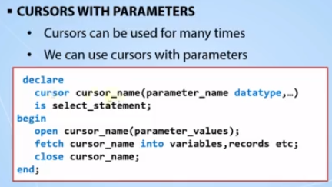

declare

cursor c_emps (p_dept_id number) is select first_name,last_name,department_name

from employees join departments using (department_id)

where department_id = p_dept_id;

v_emps c_emps%rowtype;

begin

open c_emps(20);

fetch c_emps into v_emps;

dbms_output.put_line('The employees in department of '|| v_emps.department_name|| ' are :');

close c_emps;

open c_emps(20);

loop

fetch c_emps into v_emps;

exit when c_emps%notfound;

dbms_output.put_line(v_emps.first_name|| ' ' ||v_emps.last_name);

end loop;

close c_emps;

end;

--------------- bind variables as parameters

declare

cursor c_emps (p_dept_id number) is select first_name,last_name,department_name

from employees join departments using (department_id)

where department_id = p_dept_id;

v_emps c_emps%rowtype;

begin

open c_emps(:b_emp);

fetch c_emps into v_emps;

dbms_output.put_line('The employees in department of '|| v_emps.department_name|| ' are :');

close c_emps;

open c_emps(:b_emp);

loop

fetch c_emps into v_emps;

exit when c_emps%notfound;

dbms_output.put_line(v_emps.first_name|| ' ' ||v_emps.last_name);

end loop;

close c_emps;

end;

---------------cursors with two different parameters

declare

cursor c_emps (p_dept_id number) is select first_name,last_name,department_name

from employees join departments using (department_id)

where department_id = p_dept_id;

v_emps c_emps%rowtype;

begin

open c_emps(:b_dept_id);

fetch c_emps into v_emps;

dbms_output.put_line('The employees in department of '|| v_emps.department_name|| ' are :');

close c_emps;

open c_emps(:b_dept_id);

loop

fetch c_emps into v_emps;

exit when c_emps%notfound;

dbms_output.put_line(v_emps.first_name|| ' ' ||v_emps.last_name);

end loop;

close c_emps;

open c_emps(:b_dept_id2);

fetch c_emps into v_emps;

dbms_output.put_line('The employees in department of '|| v_emps.department_name|| ' are :');

close c_emps;

open c_emps(:b_dept_id2);

loop

fetch c_emps into v_emps;

exit when c_emps%notfound;

dbms_output.put_line(v_emps.first_name|| ' ' ||v_emps.last_name);

end loop;

close c_emps;

end;

--------------- cursor with parameters - for in loops

declare

cursor c_emps (p_dept_id number) is select first_name,last_name,department_name

from employees join departments using (department_id)

where department_id = p_dept_id;

v_emps c_emps%rowtype;

begin

open c_emps(:b_dept_id);

fetch c_emps into v_emps;

dbms_output.put_line('The employees in department of '|| v_emps.department_name|| ' are :');

close c_emps;

open c_emps(:b_dept_id);

loop

fetch c_emps into v_emps;

exit when c_emps%notfound;

dbms_output.put_line(v_emps.first_name|| ' ' ||v_emps.last_name);

end loop;

close c_emps;

open c_emps(:b_dept_id2);

fetch c_emps into v_emps;

dbms_output.put_line('The employees in department of '|| v_emps.department_name|| ' are :');

close c_emps;

for i in c_emps(:b_dept_id2) loop

dbms_output.put_line(i.first_name|| ' ' ||i.last_name);

end loop;

end;

---------------cursors with multiple parameters

declare

cursor c_emps (p_dept_id number , p_job_id varchar2) is select first_name,last_name,job_id,department_name

from employees join departments using (department_id)

where department_id = p_dept_id

and job_id = p_job_id;

v_emps c_emps%rowtype;

begin

for i in c_emps(50,'ST_MAN') loop

dbms_output.put_line(i.first_name|| ' ' ||i.last_name|| ' - ' || i.job_id);

end loop;

dbms_output.put_line(' - ');

for i in c_emps(80,'SA_MAN') loop

dbms_output.put_line(i.first_name|| ' ' ||i.last_name|| ' - ' || i.job_id);

end loop;

end;

--------------- An error example of using parameter name with the column name

declare

cursor c_emps (p_dept_id number , job_id varchar2) is select first_name,last_name,job_id,department_name

from employees join departments using (department_id)

where department_id = p_dept_id

and job_id = job_id;

v_emps c_emps%rowtype;

begin

for i in c_emps(50,'ST_MAN') loop

dbms_output.put_line(i.first_name|| ' ' ||i.last_name|| ' - ' || i.job_id);

end loop;

dbms_output.put_line(' - ');

for i in c_emps(80,'SA_MAN') loop

dbms_output.put_line(i.first_name|| ' ' ||i.last_name|| ' - ' || i.job_id);

end loop;

end;

**Lecture 89 :PL SQL Cursor Attributes**

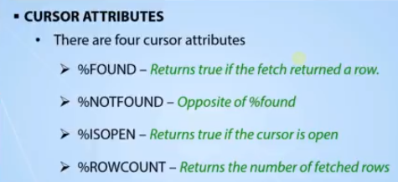

declare

cursor c_emps is select * from employees where department_id = 50;

v_emps c_emps%rowtype;

begin

if not c_emps%isopen then

open c_emps;

dbms_output.put_line('hello');

end if;

dbms_output.put_line(c_emps%rowcount);

fetch c_emps into v_emps;

dbms_output.put_line(c_emps%rowcount);

dbms_output.put_line(c_emps%rowcount);

fetch c_emps into v_emps;

dbms_output.put_line(c_emps%rowcount);

close c_emps;

open c_emps;

loop

fetch c_emps into v_emps;

exit when c_emps%notfound or c_emps%rowcount>5;

dbms_output.put_line(c_emps%rowcount|| ' ' ||v_emps.first_name|| ' ' ||v_emps.last_name);

end loop;

close c_emps;

end;

**Lecture 91: For Update Clause**

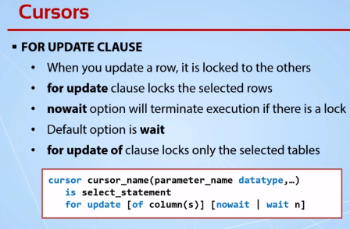

grant create session to my_user;

grant select any table to my_user;

grant update on hr.employees_copy to my_user;

grant update on hr.departments to my_user;

UPDATE EMPLOYEES_COPY SET PHONE_NUMBER = '1' WHERE EMPLOYEE_ID = 100;

declare

cursor c_emps is select employee_id,first_name,last_name,department_name

from employees_copy join departments using (department_id)

where employee_id in (100,101,102)

for update;

begin

/* for r_emps in c_emps loop

update employees_copy set phone_number = 3

where employee_id = r_emps.employee_id;

end loop; */

open c_emps;

end;

--------------- example of wait with second

declare

cursor c_emps is select employee_id,first_name,last_name,department_name

from employees_copy join departments using (department_id)

where employee_id in (100,101,102)

for update of employees_copy.phone_number,

departments.location_id wait 5;

begin

/* for r_emps in c_emps loop

update employees_copy set phone_number = 3

where employee_id = r_emps.employee_id;

end loop; */

open c_emps;

end;

---------------example of nowait

declare

cursor c_emps is select employee_id,first_name,last_name,department_name

from employees_copy join departments using (department_id)

where employee_id in (100,101,102)

for update of employees_copy.phone_number,

departments.location_id nowait;

begin

/* for r_emps in c_emps loop

update employees_copy set phone_number = 3

where employee_id = r_emps.employee_id;

end loop; */

open c_emps;

end;

**Lecture 93: Where Current Clause**

This clause makes the delete and update operation faster using the rowed;

declare

cursor c_emps is select * from employees

where department_id = 30 for update;

begin

for r_emps in c_emps loop

update employees set salary = salary + 60

where current of c_emps;

end loop;

end;

---------------Wrong example of using where current of clause

declare

cursor c_emps is select e.* from employees e, departments d

where

e.department_id = d.department_id

and e.department_id = 30 for update;

begin

for r_emps in c_emps loop

update employees set salary = salary + 60

where current of c_emps;

end loop;

end;

---------------An example of using rowid like where current of clause

declare

cursor c_emps is select e.rowid,e.salary from employees e, departments d

where

e.department_id = d.department_id

and e.department_id = 30 for update;

begin

for r_emps in c_emps loop

update employees set salary = salary + 60

where rowid = r_emps.rowid;

end loop;

end;

**Lecture 95 : Reference Cursors**

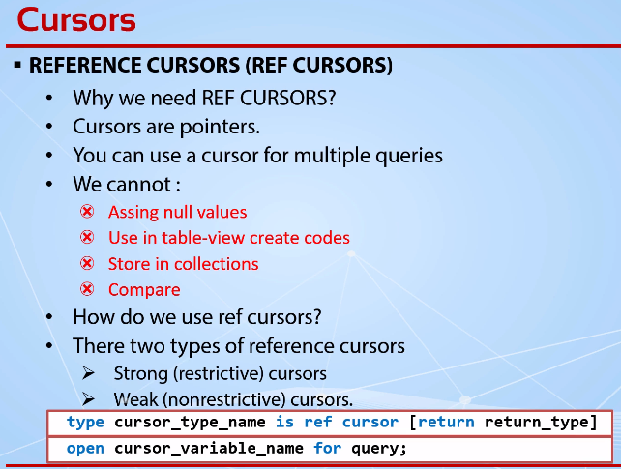

**Weak Cursor_Type-🡪sys_refcursor**

declare

type t_emps is ref cursor return employees%rowtype;

rc_emps t_emps;

r_emps employees%rowtype;

begin

open rc_emps for select * from employees;

loop

fetch rc_emps into r_emps;

exit when rc_emps%notfound;

dbms_output.put_line(r_emps.first_name|| ' ' || r_emps.last_name);

end loop;

close rc_emps;

end;

--------------- in two different queries

declare

type t_emps is ref cursor return employees%rowtype;

rc_emps t_emps;

r_emps employees%rowtype;

begin

open rc_emps for select * from retired_employees;

loop

fetch rc_emps into r_emps;

exit when rc_emps%notfound;

dbms_output.put_line(r_emps.first_name|| ' ' || r_emps.last_name);

end loop;

close rc_emps;

dbms_output.put_line('--------------');

open rc_emps for select * from employees where job_id = 'IT_PROG';

loop

fetch rc_emps into r_emps;

exit when rc_emps%notfound;

dbms_output.put_line(r_emps.first_name|| ' ' || r_emps.last_name);

end loop;

close rc_emps;

end;

---------------Example of using with %type when declaring records first

declare

r_emps employees%rowtype;

type t_emps is ref cursor return r_emps%type;

rc_emps t_emps;

--type t_emps2 is ref cursor return rc_emps%rowtype;

begin

open rc_emps for select * from retired_employees;

loop

fetch rc_emps into r_emps;

exit when rc_emps%notfound;

dbms_output.put_line(r_emps.first_name|| ' ' || r_emps.last_name);

end loop;

close rc_emps;

dbms_output.put_line('--------------');

open rc_emps for select * from employees where job_id = 'IT_PROG';

loop

fetch rc_emps into r_emps;

exit when rc_emps%notfound;

dbms_output.put_line(r_emps.first_name|| ' ' || r_emps.last_name);

end loop;

close rc_emps;

end;

---------------manually declared record type with cursors example

declare

type ty_emps is record (e_id number,

first_name employees.first_name%type,

last_name employees.last_name%type,

department_name departments.department_name%type);

r_emps ty_emps;

type t_emps is ref cursor return ty_emps;

rc_emps t_emps;

begin

open rc_emps for select employee_id,first_name,last_name,department_name

from employees join departments using (department_id);

loop

fetch rc_emps into r_emps;

exit when rc_emps%notfound;

dbms_output.put_line(r_emps.first_name|| ' ' || r_emps.last_name||

' is at the department of : '|| r_emps.department_name );

end loop;

close rc_emps;

end;

---------------first example of weak ref cursors

declare

type ty_emps is record (e_id number,

first_name employees.first_name%type,

last_name employees.last_name%type,

department_name departments.department_name%type);

r_emps ty_emps;

type t_emps is ref cursor;

rc_emps t_emps;

q varchar2(200);

begin

q := 'select employee_id,first_name,last_name,department_name

from employees join departments using (department_id)';

open rc_emps for q;

loop

fetch rc_emps into r_emps;

exit when rc_emps%notfound;

dbms_output.put_line(r_emps.first_name|| ' ' || r_emps.last_name||

' is at the department of : '|| r_emps.department_name );

end loop;

close rc_emps;

end;

--------------- bind variables with cursors example

declare

type ty_emps is record (e_id number,

first_name employees.first_name%type,

last_name employees.last_name%type,

department_name departments.department_name%type);

r_emps ty_emps;

type t_emps is ref cursor;

rc_emps t_emps;

r_depts departments%rowtype;

--r t_emps%rowtype;

q varchar2(200);

begin

q := 'select employee_id,first_name,last_name,department_name

from employees join departments using (department_id)

where department_id = :t';

open rc_emps for q using '50';

loop

fetch rc_emps into r_emps;

exit when rc_emps%notfound;

dbms_output.put_line(r_emps.first_name|| ' ' || r_emps.last_name||

' is at the department of : '|| r_emps.department_name );

end loop;

close rc_emps;

open rc_emps for select * from departments;

loop

fetch rc_emps into r_depts;

exit when rc_emps%notfound;

dbms_output.put_line(r_depts.department_id|| ' ' || r_depts.department_name);

end loop;

close rc_emps;

end;

---------------sys_refcursor example

declare

type ty_emps is record (e_id number,

first_name employees.first_name%type,

last_name employees.last_name%type,

department_name departments.department_name%type);

r_emps ty_emps;

-- type t_emps is ref cursor;

rc_emps sys_refcursor;

r_depts departments%rowtype;

--r t_emps%rowtype;

q varchar2(200);

begin

q := 'select employee_id,first_name,last_name,department_name

from employees join departments using (department_id)

where department_id = :t';

open rc_emps for q using '50';

loop

fetch rc_emps into r_emps;

exit when rc_emps%notfound;

dbms_output.put_line(r_emps.first_name|| ' ' || r_emps.last_name||

' is at the department of : '|| r_emps.department_name );

end loop;

close rc_emps;

open rc_emps for select * from departments;

loop

fetch rc_emps into r_depts;

exit when rc_emps%notfound;

dbms_output.put_line(r_depts.department_id|| ' ' || r_depts.department_name);

end loop;

close rc_emps;

end;

**Lecture 97: What Are the Exceptions**

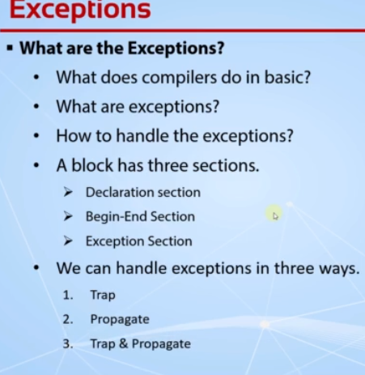

**Lecture 98: What Are the Exceptions(code Sample)**

declare

v_name varchar2(6);

begin

select first_name into v_name from employees where employee_id = 50;

dbms_output.put_line('Hello');

end;

**Lecture 99: Handling the exception**

Exception handler need to be unique.

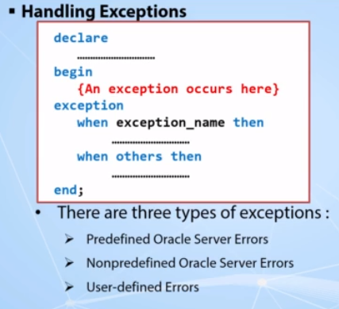

declare

v_name varchar2(6);

begin

select first_name into v_name from employees where employee_id = 50;

dbms_output.put_line('Hello');

exception

when no_data_found then

dbms_output.put_line('There is no employee with the selected id');

end;

----------------- Handling multiple exceptions

declare

v_name varchar2(6);

v_department_name varchar2(100);

begin

select first_name into v_name from employees where employee_id = 100;

select department_id into v_department_name from employees where first_name = v_name;

dbms_output.put_line('Hello '|| v_name || '. Your department id is : '|| v_department_name );

exception

when no_data_found then

dbms_output.put_line('There is no employee with the selected id');

when too_many_rows then

dbms_output.put_line('There are more than one employees with the name '|| v_name);

dbms_output.put_line('Try with a different employee');

end;

----------------- when others then example

declare

v_name varchar2(6);

v_department_name varchar2(100);

begin

select first_name into v_name from employees where employee_id = 103;

select department_id into v_department_name from employees where first_name = v_name;

dbms_output.put_line('Hello '|| v_name || '. Your department id is : '|| v_department_name );

exception

when no_data_found then

dbms_output.put_line('There is no employee with the selected id');

when too_many_rows then

dbms_output.put_line('There are more than one employees with the name '|| v_name);

dbms_output.put_line('Try with a different employee');

when others then

dbms_output.put_line('An unexpected error happened. Connect with the programmer..');

end;

----------------- sqlerrm & sqlcode example

declare

v_name varchar2(6);

v_department_name varchar2(100);

begin

select first_name into v_name from employees where employee_id = 103;

select department_id into v_department_name from employees where first_name = v_name;

dbms_output.put_line('Hello '|| v_name || '. Your department id is : '|| v_department_name );

exception

when no_data_found then

dbms_output.put_line('There is no employee with the selected id');

when too_many_rows then

dbms_output.put_line('There are more than one employees with the name '|| v_name);

dbms_output.put_line('Try with a different employee');

when others then

dbms_output.put_line('An unexpected error happened. Connect with the programmer..');

dbms_output.put_line(sqlcode || ' ---> '|| sqlerrm);

end;

----------------- Inner block exception example

declare

v_name varchar2(6);

v_department_name varchar2(100);

begin

select first_name into v_name from employees where employee_id = 100;

begin

select department_id into v_department_name from employees where first_name = v_name;

exception

when too_many_rows then

v_department_name := 'Error in department_name';

end;

dbms_output.put_line('Hello '|| v_name || '. Your department id is : '|| v_department_name );

exception

when no_data_found then

dbms_output.put_line('There is no employee with the selected id');

when too_many_rows then

dbms_output.put_line('There are more than one employees with the name '|| v_name);

dbms_output.put_line('Try with a different employee');

when others then

dbms_output.put_line('An unexpected error happened. Connect with the programmer..');

dbms_output.put_line(sqlcode || ' ---> '|| sqlerrm);

end;

/

select * from employees where first_name = 'Steven';

**Lecture 101 : Handling the Nonpredefined Exceptions**

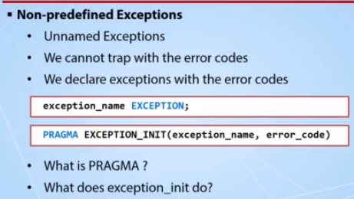

begin

UPDATE employees_copy set email = null where employee_id = 100;

end;

-----------------HANDLING a nonpredefined exception

declare

cannot_update_to_null exception;

pragma exception_init(cannot_update_to_null,-01407);

begin

UPDATE employees_copy set email = null where employee_id = 100;

exception

when cannot_update_to_null then

dbms_output.put_line('You cannot update with a null value!');

end;

**Lecture 103 : Handling & Raising User-Defined Exceptions**

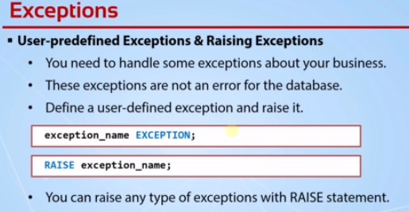

declare

too_high_salary exception;

v_salary_check pls_integer;

begin

select salary into v_salary_check from employees where employee_id = 100;

if v_salary_check > 20000 then

raise too_high_salary;

end if;

--we do our business if the salary is under 2000

dbms_output.put_line('The salary is in an acceptable range');

exception

when too_high_salary then

dbms_output.put_line('This salary is too high. You need to decrease it.');

end;

/**************** Raising a Predefined Exception *******************/

declare

too_high_salary exception;

v_salary_check pls_integer;

begin

select salary into v_salary_check from employees where employee_id = 100;

if v_salary_check > 20000 then

raise invalid_number;

end if;

--we do our business if the salary is under 2000

dbms_output.put_line('The salary is in an acceptable range');

exception

when invalid_number then

dbms_output.put_line('This salary is too high. You need to decrease it.');

end;

/****************** Raising Inside of the Exception ****************/

declare

too_high_salary exception;

v_salary_check pls_integer;

begin

select salary into v_salary_check from employees where employee_id = 100;

if v_salary_check > 20000 then

raise invalid_number;

end if;

--we do our business if the salary is under 2000

dbms_output.put_line('The salary is in an acceptable range');

exception

when invalid_number then

dbms_output.put_line('This salary is too high. You need to decrease it.');

raise;

end;

**Lecture 105: Using RAISE_APPLICATION_Error()**

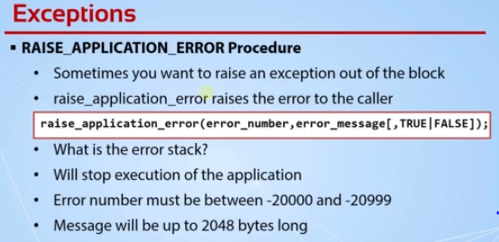

declare

too_high_salary exception;

v_salary_check pls_integer;

begin

select salary into v_salary_check from employees where employee_id = 100;

if v_salary_check > 20000 then

--raise too_high_salary;

raise_application_error(-20243,'The salary of the selected employee is too high!');

end if;

--we do our business if the salary is under 2000

dbms_output.put_line('The salary is in an acceptable range');

exception

when too_high_salary then

dbms_output.put_line('This salary is too high. You need to decrease it.');

end;

----------------- raise inside of the exception section

declare

too_high_salary exception;

v_salary_check pls_integer;

begin

select salary into v_salary_check from employees where employee_id = 100;

if v_salary_check > 20000 then

raise too_high_salary;

end if;

--we do our business if the salary is under 2000

dbms_output.put_line('The salary is in an acceptable range');

exception

when too_high_salary then

dbms_output.put_line('This salary is too high. You need to decrease it.');

raise_application_error(-01403,'The salary of the selected employee is too high!',true);

end;

**Lecture 107 : What are Functions & Procedures and Why we use?**

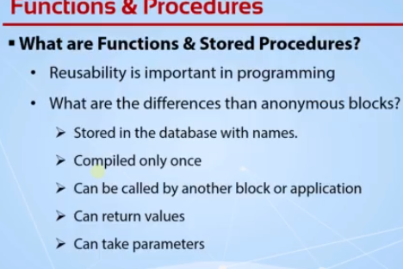

-----------------An anonymous block example

declare

cursor c_emps is select * from employees_copy for update;

v_salary_increase number:= 1.10;

v_old_salary number;

begin

for r_emp in c_emps loop

v_old_salary := r_emp.salary;

r_emp.salary := r_emp.salary*v_salary_increase + r_emp.salary * nvl(r_emp.commission_pct,0);

update employees_copy set row = r_emp where current of c_emps;

dbms_output.put_line('The salary of : '|| r_emp.employee_id

|| ' is increased from '||v_old_salary||' to '||r_emp.salary);

end loop;

end;

-----------------An anonymous block example 2

declare

cursor c_emps is select * from employees_copy for update;

v_salary_increase number:= 1.10;

v_old_salary number;

v_new_salary number;

v_salary_max_limit pls_integer := 20000;

begin

for r_emp in c_emps loop

v_old_salary := r_emp.salary;

--check salary area

v_new_salary := r_emp.salary*v_salary_increase + r_emp.salary * nvl(r_emp.commission_pct,0);

if v_new_salary > v_salary_max_limit then

RAISE_APPLICATION_ERROR(-20000, 'The new salary of '||r_emp.first_name|| ' cannot be higher than '|| v_salary_max_limit);

end if;

r_emp.salary := r_emp.salary*v_salary_increase + r_emp.salary * nvl(r_emp.commission_pct,0);

----------

update employees_copy set row = r_emp where current of c_emps;

dbms_output.put_line('The salary of : '|| r_emp.employee_id

|| ' is increased from '||v_old_salary||' to '||r_emp.salary);

end loop;

end;

**Lecture 109: Creating and Using Stored Procedures**

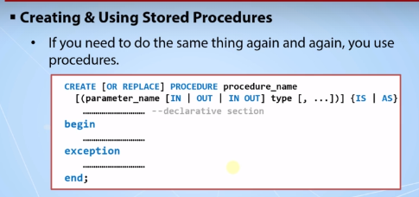

**To run the procedure ,we can run it using**

**Way 1 -🡪 execute procedure_name command**

**Way 2 -🡪**

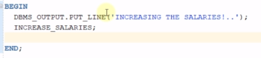

create procedure increase_salaries as

cursor c_emps is select * from employees_copy for update;

v_salary_increase number := 1.10;

v_old_salary number;

begin

for r_emp in c_emps loop

v_old_salary := r_emp.salary;

r_emp.salary := r_emp.salary * v_salary_increase + r_emp.salary * nvl(r_emp.commission_pct,0);

update employees_copy set row = r_emp where current of c_emps;

dbms_output.put_line('The salary of : '|| r_emp.employee_id

|| ' is increased from '||v_old_salary||' to '||r_emp.salary);

end loop;

end;

----------------- Multiple procedure usage

begin

dbms_output.put_line('Increasing the salaries!...');

INCREASE_SALARIES;

INCREASE_SALARIES;

INCREASE_SALARIES;

INCREASE_SALARIES;

dbms_output.put_line('All the salaries are successfully increased!...');

end;

----------------- Different procedures in one block

begin

dbms_output.put_line('Increasing the salaries!...');

INCREASE_SALARIES;

new_line;

INCREASE_SALARIES;

new_line;

INCREASE_SALARIES;

new_line;

INCREASE_SALARIES;

dbms_output.put_line('All the salaries are successfully increased!...');

end;

-----------------Creating a procedure to ease the dbms_output.put_line procedure

create procedure new_line as

begin

dbms_output.put_line('------------------------------------------');

end;

-----------------Modifying the procedure with using the OR REPLACE command.

create or replace procedure increase_salaries as

cursor c_emps is select * from employees_copy for update;

v_salary_increase number := 1.10;

v_old_salary number;

begin

for r_emp in c_emps loop

v_old_salary := r_emp.salary;

r_emp.salary := r_emp.salary * v_salary_increase + r_emp.salary * nvl(r_emp.commission_pct,0);

update employees_copy set row = r_emp where current of c_emps;

dbms_output.put_line('The salary of : '|| r_emp.employee_id

|| ' is increased from '||v_old_salary||' to '||r_emp.salary);

end loop;

dbms_output.put_line('Procedure finished executing!');

end

**Lecture 111: Using In And Out Parameters**

**IN-🡪it sends the value inside of our procedure**

**OUT🡪it gives a value from that procedure**

----------------Creating a procedure with the IN parameters

create or replace procedure increase_salaries (v_salary_increase in number, v_department_id pls_integer) as

cursor c_emps is select * from employees_copy where department_id = v_department_id for update;

v_old_salary number;

begin

for r_emp in c_emps loop

v_old_salary := r_emp.salary;

r_emp.salary := r_emp.salary * v_salary_increase + r_emp.salary * nvl(r_emp.commission_pct,0);

update employees_copy set row = r_emp where current of c_emps;

dbms_output.put_line('The salary of : '|| r_emp.employee_id

|| ' is increased from '||v_old_salary||' to '||r_emp.salary);

end loop;

dbms_output.put_line('Procedure finished executing!');

end;

----------------- Creating a procedure with the OUT parameters

create or replace procedure increase_salaries

(v_salary_increase in out number, v_department_id pls_integer, v_affected_employee_count out number) as

cursor c_emps is select * from employees_copy where department_id = v_department_id for update;

v_old_salary number;

v_sal_inc number := 0;

begin

v_affected_employee_count := 0;

for r_emp in c_emps loop

v_old_salary := r_emp.salary;

r_emp.salary := r_emp.salary * v_salary_increase + r_emp.salary * nvl(r_emp.commission_pct,0);

update employees_copy set row = r_emp where current of c_emps;

dbms_output.put_line('The salary of : '|| r_emp.employee_id

|| ' is increased from '||v_old_salary||' to '||r_emp.salary);

v_affected_employee_count := v_affected_employee_count + 1;

v_sal_inc := v_sal_inc + v_salary_increase + nvl(r_emp.commission_pct,0);

end loop;

v_salary_increase := v_sal_inc / v_affected_employee_count;

dbms_output.put_line('Procedure finished executing!');

end;

-----------------Another example of creating a procedure with the IN parameter

CREATE OR REPLACE PROCEDURE PRINT(TEXT IN VARCHAR2) IS

BEGIN

DBMS_OUTPUT.PUT_LINE(TEXT);

END;

-----------------Using the procedures that has the IN parameters

begin

PRINT('SALARY INCREASE STARTED!..');

INCREASE_SALARIES(1.15,90);

PRINT('SALARY INCREASE FINISHED!..');

end;

-----------------Using the procedure that has OUT parameters

declare

v_sal_inc number := 1.2;

v_aff_emp_count number;

begin

PRINT('SALARY INCREASE STARTED!..');

INCREASE_SALARIES(v_sal_inc,80,v_aff_emp_count);

PRINT('The affected employee count is : '|| v_aff_emp_count);

PRINT('The average salary increase is : '|| v_sal_inc || ' percent!..');

PRINT('SALARY INCREASE FINISHED!..');

end;

WE can ignore the pass parameters while calling procedure but that parameter should be in mode.

**Lecture 113: Named and Mixed Notations and Default Option**

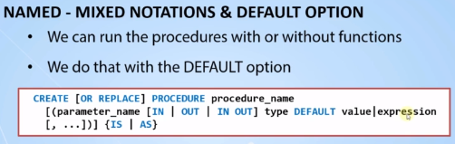

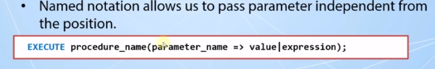

----------------- A standard procedure creation with a default value

create or replace PROCEDURE PRINT(TEXT IN VARCHAR2 := 'This is the print function!.') IS

BEGIN

DBMS_OUTPUT.PUT_LINE(TEXT);

END;

-----------------Executing a procedure without any parameter. It runs because it has a default value.

exec print();

-----------------Running a procedure with null value will not use the default value

exec print(null);

-----------------Procedure creation of a default value usage

create or replace procedure add_job(job_id pls_integer, job_title varchar2,

min_salary number default 1000, max_salary number default null) is

begin

insert into jobs values (job_id,job_title,min_salary,max_salary);

print('The job : '|| job_title || ' is inserted!..');

end;

-----------------A standard run of the procedure

exec ADD_JOB('IT_DIR','IT Director',5000,20000);

-----------------Running a procedure with using the default values

exec ADD_JOB('IT_DIR2','IT Director',5000);

-----------------Running a procedure with the named notation

exec ADD_JOB('IT_DIR5','IT Director',max_salary=>10000);

-----------------Running a procedure with the named notation example 2

exec ADD_JOB(job_title=>'IT Director',job_id=>'IT_DIR7',max_salary=>10000 , min_salary=>500);

**Lecture 115: Creating and Using Functions**

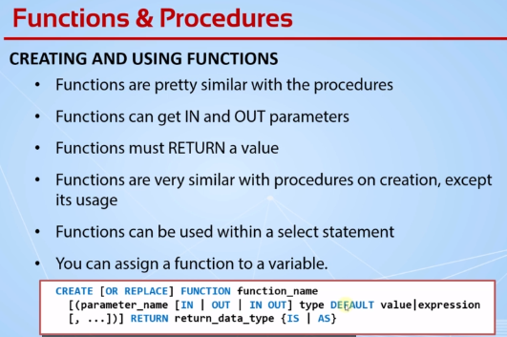

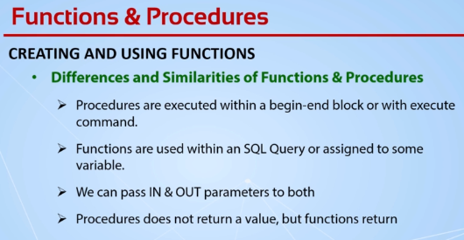

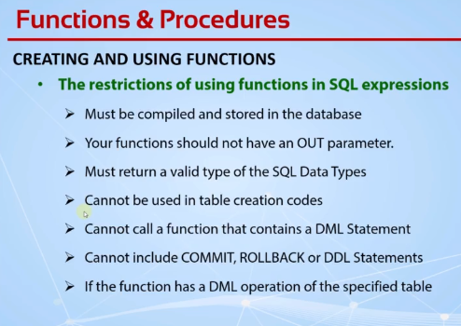

CREATE OR REPLACE FUNCTION get_avg_sal (p_dept_id departments.department_id%type) RETURN number AS

v_avg_sal number;

BEGIN

select avg(salary) into v_avg_sal from employees where department_id = p_dept_id;

RETURN v_avg_sal;

END get_avg_sal;

----------------- using a function in begin-end block

declare

v_avg_salary number;

begin

v_avg_salary := get_avg_sal(50);

dbms_output.put_line(v_avg_salary);

end;

----------------- using functions in a select clause

select employee_id,first_name,salary,department_id,get_avg_sal(department_id) avg_sal from employees;

----------------- using functions in group by, order by, where clauses

select get_avg_sal(department_id) from employees

where salary > get_avg_sal(department_id)

group by get_avg_sal(department_id)

order by get_avg_sal(department_id);

----------------- dropping a function

drop function get_avg_sal;

**Lecture 118 : Local Subprograms**

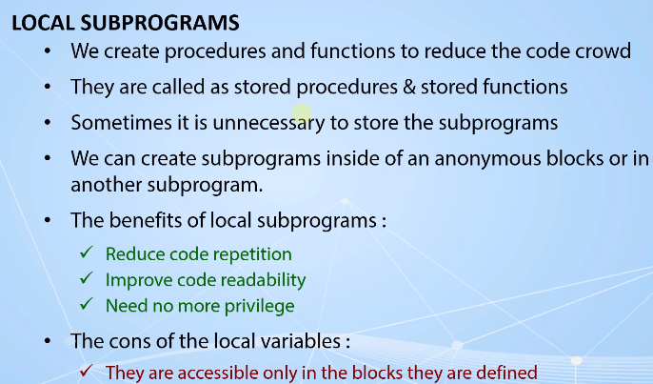

**WE can create a function inside the procedure**

**The subprograms need to be end of the declaration area.**

**Lecture 119 : Local Subprograms(Code Sample)**

/*Creating and Using Subprograms in Anonymous Blocks - False Usage */

create table emps_high_paid as select * from employees where 1=2;

/

declare

procedure insert_high_paid_emp(emp_id employees.employee_id%type) is

emp employees%rowtype;

begin

emp := get_emp(emp_id);

insert into emps_high_paid values emp;

end;

function get_emp(emp_num employees.employee_id%type) return employees%rowtype is

emp employees%rowtype;

begin

select * into emp from employees where employee_id = emp_num;

return emp;

end;

begin

for r_emp in (select * from employees) loop

if r_emp.salary > 15000 then

insert_high_paid_emp(r_emp.employee_id);

end if;

end loop;

end;

/* Creating and Using Subprograms in Anonymous Blocks - True Usage */

declare

function get_emp(emp_num employees.employee_id%type) return employees%rowtype is

emp employees%rowtype;

begin

select * into emp from employees where employee_id = emp_num;

return emp;

end;

procedure insert_high_paid_emp(emp_id employees.employee_id%type) is

emp employees%rowtype;

begin

emp := get_emp(emp_id);

insert into emps_high_paid values emp;

end;

begin

for r_emp in (select * from employees) loop

if r_emp.salary > 15000 then

insert_high_paid_emp(r_emp.employee_id);

end if;

end loop;

end;

/*********************** The Scope of Emp Record **********************/

declare

procedure insert_high_paid_emp(emp_id employees.employee_id%type) is

emp employees%rowtype;

e_id number;

function get_emp(emp_num employees.employee_id%type) return employees%rowtype is

begin

select * into emp from employees where employee_id = emp_num;

return emp;

end;

begin

emp := get_emp(emp_id);

insert into emps_high_paid values emp;

end;

begin

for r_emp in (select * from employees) loop

if r_emp.salary > 15000 then

insert_high_paid_emp(r_emp.employee_id);

end if;

end loop;

end;

**Lecture 120 : Overloading the Subprograms**

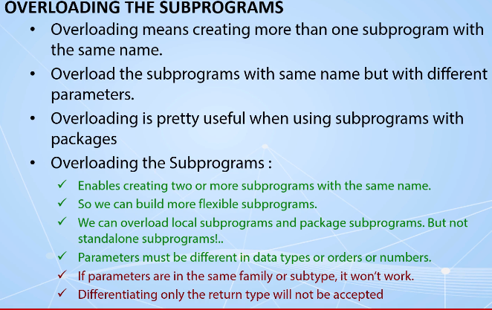

declare

procedure insert_high_paid_emp(p_emp employees%rowtype) is

emp employees%rowtype;

e_id number;

function get_emp(emp_num employees.employee_id%type) return employees%rowtype is

begin

select * into emp from employees where employee_id = emp_num;

return emp;

end;

function get_emp(emp_email employees.email%type) return employees%rowtype is

begin

select * into emp from employees where email = emp_email;

return emp;

end;

begin

emp := get_emp(p_emp.employee_id);

insert into emps_high_paid values emp;

end;

begin

for r_emp in (select * from employees) loop

if r_emp.salary > 15000 then

insert_high_paid_emp(r_emp);

end if;

end loop;

end;

----------------- overloading with multiple usages

declare

procedure insert_high_paid_emp(p_emp employees%rowtype) is

emp employees%rowtype;

e_id number;

function get_emp(emp_num employees.employee_id%type) return employees%rowtype is

begin

select * into emp from employees where employee_id = emp_num;

return emp;

end;

function get_emp(emp_email employees.email%type) return employees%rowtype is

begin

select * into emp from employees where email = emp_email;

return emp;

end;

function get_emp(f_name varchar2, l_name varchar2) return employees%rowtype is

begin

select * into emp from employees where first_name = f_name and last_name = l_name;

return emp;

end;

begin

emp := get_emp(p_emp.employee_id);

insert into emps_high_paid values emp;

emp := get_emp(p_emp.email);

insert into emps_high_paid values emp;

emp := get_emp(p_emp.first_name,p_emp.last_name);

insert into emps_high_paid values emp;

end;

begin

for r_emp in (select * from employees) loop

if r_emp.salary > 15000 then

insert_high_paid_emp(r_emp);

end if;

end loop;

end;

**Lecture 122 : Handling the Exceptions in Subprograms**

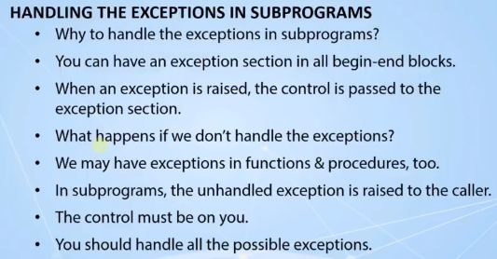

----------------- An unhandled exception in function

create or replace function get_emp(emp_num employees.employee_id%type) return employees%rowtype is

emp employees%rowtype;

begin

select * into emp from employees where employee_id = emp_num;

return emp;

end;

----------------- calling that function in an anonymous block

declare

v_emp employees%rowtype;

begin

dbms_output.put_line('Fetching the employee data!..');

v_emp := get_emp(10);

dbms_output.put_line('Some information of the employee are : ');

dbms_output.put_line('The name of the employee is : '|| v_emp.first_name);

dbms_output.put_line('The email of the employee is : '|| v_emp.email);

dbms_output.put_line('The salary of the employee is : '|| v_emp.salary);

end;

----------------- hanling the exception wihout the return clause - not working

create or replace function get_emp(emp_num employees.employee_id%type) return employees%rowtype is

emp employees%rowtype;

begin

select * into emp from employees where employee_id = emp_num;

return emp;

exception

when no_data_found then

dbms_output.put_line('There is no employee with the id '|| emp_num);

end;

----------------- handling and raising the exception

create or replace function get_emp(emp_num employees.employee_id%type) return employees%rowtype is

emp employees%rowtype;

begin

select * into emp from employees where employee_id = emp_num;

return emp;

exception

when no_data_found then

dbms_output.put_line('There is no employee with the id '|| emp_num);

raise no_data_found;

end;

----------------- handling all possible exception cases

create or replace function get_emp(emp_num employees.employee_id%type) return employees%rowtype is

emp employees%rowtype;

begin

select * into emp from employees where employee_id = emp_num;

return emp;

exception

when no_data_found then

dbms_output.put_line('There is no employee with the id '|| emp_num);

raise no_data_found;

when others then

dbms_output.put_line('Something unexpected happened!.');

return null;

end;

**Lecture 125: Regular and Pipelined Table Functions**

A regular table function creates the entire collection in the memory and returns it after creating the collection.

This property can be used in data warehousing

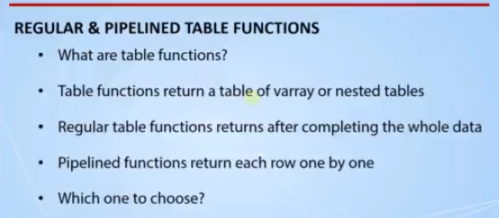

CREATE TYPE t_day AS OBJECT (

v_date DATE,

v_day_number INT

);

----------------- creating a nested table type

CREATE TYPE t_days_tab IS TABLE OF t_day;

----------------- creating a regular table function

CREATE OR REPLACE FUNCTION f_get_days(p_start_date DATE , p_day_number INT)

RETURN t_days_tab IS

v_days t_days_tab := t_days_tab();

BEGIN

FOR i IN 1 .. p_day_number LOOP

v_days.EXTEND();

v_days(i) := t_day(p_start_date + i, to_number(to_char(p_start_date + i, 'DDD')));

END LOOP;

RETURN v_days;

END;

----------------- querying from the regular table function

select * from table(f_get_days(sysdate,1000000));

----------------- querying from the regular table function without the table operator

select * from f_get_days(sysdate,1000000);

----------------- creating a pipelined table function

create or replace function f_get_days_piped (p_start_date date , p_day_number int)

return t_days_tab PIPELINED is

begin

for i in 1 .. p_day_number loop

PIPE ROW (t_day(p_start_date + i,

to_number(to_char(p_start_date + i,'DDD'))));

end loop;

RETURN;

end;

----------------- querying from the pipelined table function

select * from f_get_days_piped(sysdate,1000000)

**Lecture 127: What Are Packages?**

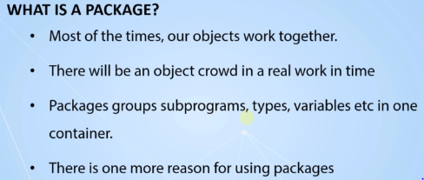

SGA-🡪System Global Area

Variables in the package are the global variable.It will exist until the session ends.

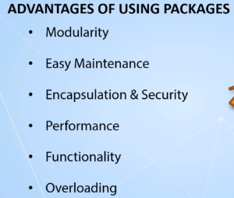

**Lecture 128 : Creating & Using & Modifying & Removing the Packages**

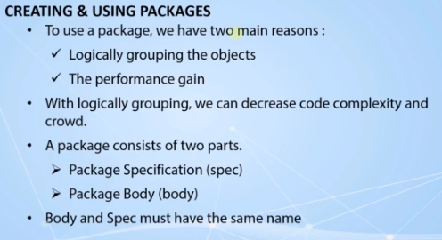

**If a variable or a subprogram or any other object is not declared in the package spec,it is not visible to the others.Means only the package body can use these objects.So these objects are considered as private objects.**

**If there is not any subprograms declared in the package spec,so there is no need to create a package body for that package**

**The way to reach to the package body is calling the name in the package spec.**

**If the package spec does not refer to any subprogram in the package body,that body is completely useless.**

**The spec is designed for providing some global objects to the others.**

**There are 2 ways to create a package**

**1.using the sqldeveloper tool**

**2. Using worksheet directly**

**In SQL Developer software-🡪choose the package option-🡪create a package**

**Click on the pacakage which is created and choose the option create body**

----------------- Creating first package specification

CREATE OR REPLACE

PACKAGE EMP AS

v_salary_increase_rate number := 0.057;

cursor cur_emps is select * from employees;

procedure increase_salaries;

function get_avg_sal(p_dept_id int) return number;

END EMP;

----------------- Creating the package body

CREATE OR REPLACE

PACKAGE BODY EMP AS

procedure increase_salaries AS

BEGIN

for r1 in cur_emps loop

update employees_copy set salary = salary + salary * v_salary_increase_rate;

end loop;

END increase_salaries;

function get_avg_sal(p_dept_id int) return number AS

v_avg_sal number := 0;

BEGIN

select avg(salary) into v_avg_sal from employees_copy where

department_id = p_dept_id;

RETURN v_avg_sal;

END get_avg_sal;

END EMP;

----------------- using the subprograms in packages

exec EMP_PKG.increase_salaries;

----------------- using the variables in packages

begin

dbms_output.put_line(emp_pkg.get_avg_sal(50));

dbms_output.put_line(emp_pkg.v_salary_increase_rate);

end;

**Lecture 130 ; Visibility of Package Objects**

**If a variable is declared inside a subprogram then that variable is local variable**

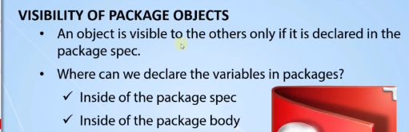

**The varaiables declared inside the package body ,these variables are private scope.**

--------------------------------VISIBILITY OF VARIABLES IN PACKAGES--------------------------

---------------------------------------------------------------------------------------------

create or replace PACKAGE BODY EMP_PKG AS

v_sal_inc int := 500;

v_sal_inc2 int := 500;

procedure print_test is

begin

dbms_output.put_line('Test : '|| v_sal_inc);

end;

procedure increase_salaries AS

BEGIN

for r1 in cur_emps loop

update employees_copy set salary = salary + salary * v_salary_increase_rate

where employee_id = r1.employee_id;

end loop;

END increase_salaries;

function get_avg_sal(p_dept_id int) return number AS

v_avg_sal number := 0;

BEGIN

print_test;

select avg(salary) into v_avg_sal from employees_copy where

department_id = p_dept_id;

RETURN v_avg_sal;

END get_avg_sal;

END EMP_PKG;

-----------------

create or replace PACKAGE BODY EMP_PKG AS

v_sal_inc int := 500;

v_sal_inc2 int := 500;

function get_sal(e_id employees.employee_id%type) return number;

procedure print_test is

begin

dbms_output.put_line('Test : '|| v_sal_inc);

dbms_output.put_line('Test salary : '|| get_sal(102));

end;

procedure increase_salaries AS

BEGIN

for r1 in cur_emps loop

update employees_copy set salary = salary + salary * v_salary_increase_rate

where employee_id = r1.employee_id;

end loop;

END increase_salaries;

function get_avg_sal(p_dept_id int) return number AS

v_avg_sal number := 0;

BEGIN

print_test;

select avg(salary) into v_avg_sal from employees_copy where

department_id = p_dept_id;

RETURN v_avg_sal;

END get_avg_sal;

function get_sal(e_id employees.employee_id%type) return number is

v_sal number := 0;

begin

select salary into v_sal from employees where employee_id = e_id;

end;

end;

**Lecture 132 : Illegal Object Reference & Forward Declaration**

**the call the function which is defined after the calling function.Which is not allowed in PL/SQL.**

**We can declare the functions in the package body at the start of the package body means for**

**Lecture 133 : Package Installation**

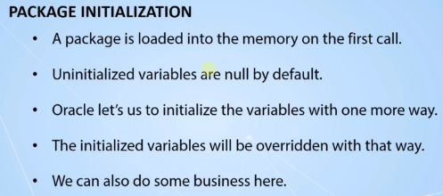

**Lecture 134 : Persistent State**

**PGA_--> Program Global Area -🡪(stores the variables,functions and codes of a user in a single session).This area is private for others.**

**SGA-🡪System Global Area🡪(Private variables stored in this).**

**When a package is referenced,the whole**

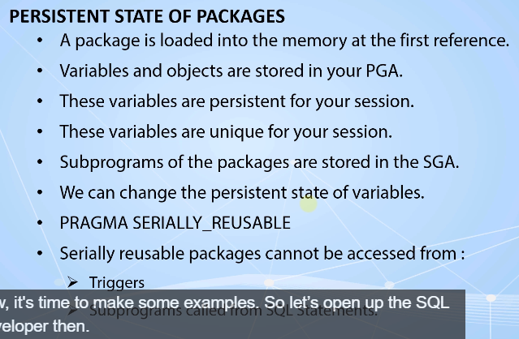

----------------------------------PERSISTENT STATE OF PACKAGES-------------------------------

---------------------------------------------------------------------------------------------

-----------------

execute dbms_output.put_line(constants_pkg.v_salary_increase);

grant execute on constants_pkg to my_user;

revoke execute on constants_pkg from my_user;

-----------------

-----------------

begin

constants_pkg.v_company_name := 'ACME';

dbms_output.put_line(constants_pkg.v_company_name);

dbms_lock.sleep(20);

end;

exec dbms_output.put_line(constants_pkg.v_company_name);

-----------------

create or replace package constants_pkg is

PRAGMA SERIALLY_REUSABLE;

v_salary_increase constant number:= 0.04;

cursor cur_emps is select * from employees;

t_emps_type employees%rowtype;

v_company_name varchar2(20) := 'ORACLE';

end;

-----------------

begin

constants_pkg.v_company_name := 'ACME';

dbms_output.put_line(constants_pkg.v_company_name);

dbms_lock.sleep(20);

end;

-----------------

declare

v_emp employees%rowtype;

begin

open constants_pkg.cur_emps;

fetch constants_pkg.cur_emps into v_emp;

dbms_output.put_line(v_emp.first_name);

close constants_pkg.cur_emps;

end;

-----------------

declare

v_emp employees%rowtype;

begin

fetch constants_pkg.cur_emps into v_emp;

dbms_output.put_line(v_emp.first_name);

end;

**Lecture 139: Using Collections In PL/SQL**

/***************** The Complete PL/SQL Bootcamp ********************

* Author : Oracle Master Training *

* Course : The Complete Oracle PL/SQL Bootcamp *

* Lecture : Using Collections in PL/SQL Packages *

*******************************************************************/

CREATE OR REPLACE PACKAGE emp_pkg AS

TYPE emp_table_type IS TABLE OF employees%rowtype INDEX BY PLS_INTEGER;

v_salary_increase_rate NUMBER := 1000;

v_min_employee_salary NUMBER := 5000;

CURSOR cur_emps IS

SELECT * FROM employees;

PROCEDURE increase_salaries;

FUNCTION get_avg_sal(p_dept_id int) RETURN NUMBER;

v_test INT := 4;

FUNCTION get_employees RETURN emp_table_type;

FUNCTION get_employees_tobe_incremented RETURN emp_table_type;

PROCEDURE increase_low_salaries;

FUNCTION arrange_for_min_salary(v_emp employees%rowtype) RETURN employees%rowtype;

END EMP_PKG;

/************************** Package Body ***************************/

CREATE OR REPLACE PACKAGE BODY emp_pkg AS

v_sal_inc INT := 500;

v_sal_inc2 INT := 500;

FUNCTION get_sal(e_id employees.employee_id%TYPE) RETURN NUMBER;

PROCEDURE print_test IS

BEGIN

dbms_output.put_line('Test : '|| v_sal_inc);

dbms_output.put_line('Tests salary :'|| get_sal(102));

END;

PROCEDURE increase_salaries AS

BEGIN

FOR r1 IN cur_emps LOOP

UPDATE employees_copy

SET salary = salary + salary * v_salary_increase_rate

WHERE employee_id = r1.employee_id;

END LOOP;

END increase_salaries;

FUNCTION get_avg_sal(p_dept_id int) RETURN NUMBER AS

v_avg_sal number := 0;

BEGIN

print_test;

SELECT avg(salary)

INTO v_avg_sal

FROM employees_copy

WHERE department_id = p_dept_id;

RETURN v_avg_sal;

END get_avg_sal;

FUNCTION get_sal(e_id employees.employee_id%TYPE) RETURN NUMBER IS

v_sal number := 0;

BEGIN

SELECT salary

INTO v_sal

FROM employees

WHERE employee_id = e_id;

RETURN v_sal;

END;

/* This function returns all the employees in employees table */

FUNCTION get_employees RETURN emp_table_type IS

v_emps emp_table_type;

BEGIN

FOR cur_emps IN (SELECT * FROM employees_copy) LOOP

v_emps(cur_emps.employee_id) := cur_emps;

END LOOP;

RETURN v_emps;

end;

/*

This function returns the employees which are under the minimum salary

of the company standards and to be incremented by the new minimum salary

*/

FUNCTION get_employees_tobe_incremented RETURN emp_table_type IS

v_emps emp_table_type;

i employees.employee_id%TYPE;

BEGIN

v_emps := get_employees;

i := v_emps.first;

WHILE i IS NOT NULL LOOP

IF v_emps(i).salary > v_min_employee_salary THEN

v_emps.delete(i);

END IF;

i := v_emps.next(i);

END LOOP;

RETURN v_emps;

END;

/*

This procedure increases the salary of the employees

who has a less salary then the company standard.

*/

PROCEDURE increase_low_salaries AS

v_emps emp_table_type;

v_emp employees%rowtype;

i employees.employee_id%type;

BEGIN

v_emps := get_employees_tobe_incremented;

i := v_emps.first;

WHILE i is not null loop

v_emp := arrange_for_min_salary(v_emps(i));

UPDATE employees_copy

SET row = v_emp

WHERE employee_id = i;

i := v_emps.next(i);

END LOOP;

END increase_low_salaries;

/*

This function returns the employee by arranging the salary based on the

company standard.

*/

FUNCTION arrange_for_min_salary(v_emp in out employees%rowtype) RETURN employees%rowtype IS

BEGIN

v_emp.salary := v_emp.salary + v_salary_increase_rate;

IF v_emp.salary < v_min_employee_salary THEN

v_emp.salary := v_min_employee_salary;

END IF;

RETURN v_emp;

END;

/***************************************************************/

BEGIN

v_salary_increase_rate := 500;

INSERT INTO logs VALUES('EMP_PKG','Package initialized!',sysdate);

END emp_pkg;

**Lecture 140: How Can I find the Package ?**

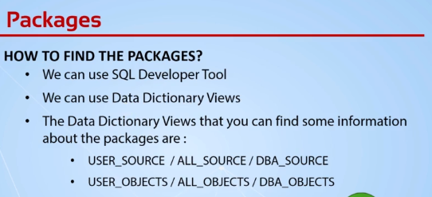

**Select * from user_source;**

**Select * from user_objects where object_type=’PACKAGE_BODY’ and**

**Object_name=’EMP_PKG’**

**Select * from user_objects where status=’invalid’**

**Lecture 141: What Are Triggers and Trigger Types**

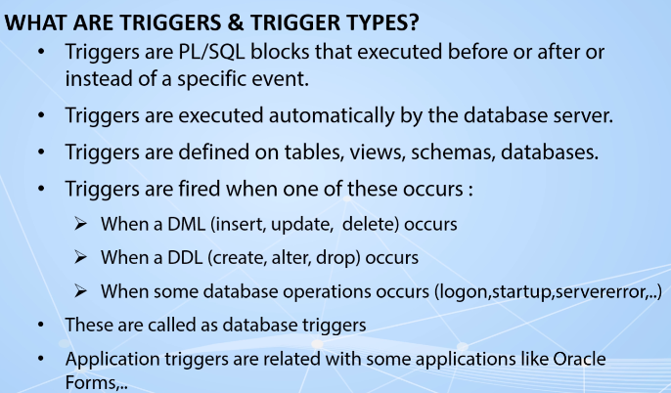

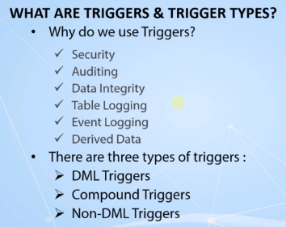

**Lecture 142 : Understanding of DML Triggers**

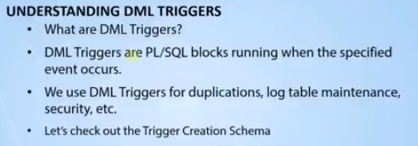

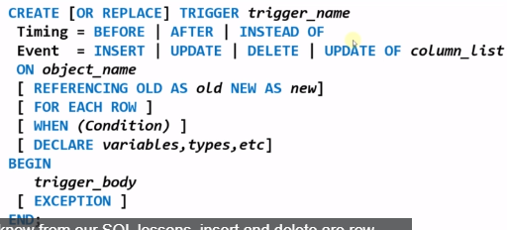

We cannot choose the update and update of event at the same time.

Object can be table or view or

Call -🡪 is used to call procedure in a trigger body

**Lecture 143 : Specifying the Timing of Triggers**

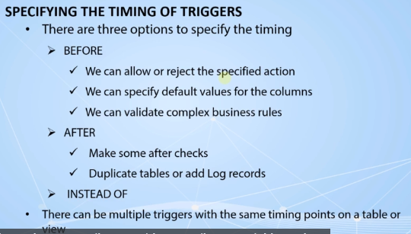

----------------- The create code of the first trigger

create or replace trigger first_trigger

before insert or update on employees_copy

begin

dbms_output.put_line('An insert or update occurred in employees_copy table!.');

end;

----------------- sql commands to or not to run the trigger

update employees_copy set salary = salary + 100;

delete from employees_copy;

**Lecture 145 : Statement and Row Level Triggers**

**Statement Level Triggers --🡪It can be executed once for all the rows updation**

**Statement level trigger is by default we don’t need to mention anything for that.**

**Row Level Triggers --🡪It can be executed for all the rows updation**

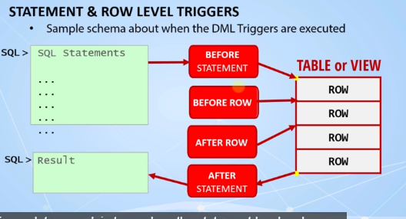

**----------------- before statement level trigger example**

**create or replace trigger before_statement_emp_cpy**

**before insert or update on employees_copy**

**begin**

**dbms_output.put_line('Before Statement Trigger is Fired!.');**

**end;**

**----------------- after statement level trigger example**

**create or replace trigger after_statement_emp_cpy**

**after insert or update on employees_copy**

**begin**

**dbms_output.put_line('After Statement Trigger is Fired!.');**

**end;**

**----------------- before row level trigger example**

**create or replace trigger before_row_emp_cpy**

**before insert or update on employees_copy**

**for each row**

**begin**

**dbms_output.put_line('Before Row Trigger is Fired!.');**

**end;**

**----------------- after row level trigger example**

**create or replace trigger after_row_emp_cpy**

**after insert or update on employees_copy**

**for each row**

**begin**

**dbms_output.put_line('After Row Trigger is Fired!.');**

**end;**

**----------------- sql queries used in this lecture**

**update employees_copy set salary = salary + 100 where employee_id = 100;**

**update employees_copy set salary = salary + 100 where employee_id = 99;**

**update employees_copy set salary = salary + 100**

**where department_id = 30;**

**Lecture 147 : Using New and Old Qualifiers in Triggers**

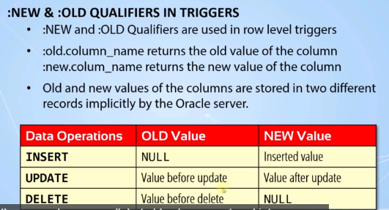

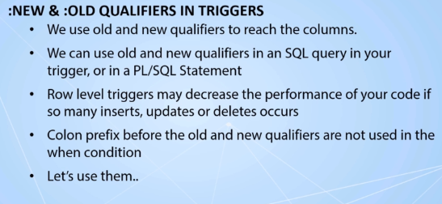

create or replace trigger before_row_emp_cpy

before insert or update or delete on employees_copy

referencing old as O new as N

for each row

begin

dbms_output.put_line('Before Row Trigger is Fired!.');

dbms_output.put_line('The Salary of Employee '||:o.employee_id

||' -> Before:'|| :o.salary||' After:'||:n.salary);

end;

**Lecture 149: Using Conditional Predicates**

create or replace trigger before_row_emp_cpy

before insert or update or delete on employees_copy

referencing old as O new as N

for each row

begin

dbms_output.put_line('Before Row Trigger is Fired!.');

dbms_output.put_line('The Salary of Employee '||:o.employee_id

||' -> Before:'|| :o.salary||' After:'||:n.salary);

if inserting then

dbms_output.put_line('An INSERT occurred on employees_copy table');

elsif deleting then

dbms_output.put_line('A DELETE occurred on employees_copy table');

elsif updating ('salary') then

dbms_output.put_line('A DELETE occurred on the salary column');

elsif updating then

dbms_output.put_line('An UPDATE occurred on employees_copy table');

end if;

end;

**Lecture 151 : Using RAISE_APPLICATION_Error**

create or replace trigger before_row_emp_cpy

before insert or update or delete on employees_copy

referencing old as O new as N

for each row

begin

dbms_output.put_line('Before Row Trigger is Fired!.');

dbms_output.put_line('The Salary of Employee '||:o.employee_id

||' -> Before:'|| :o.salary||' After:'||:n.salary);

if inserting then

if :n.hire_date > sysdate then

raise_application_error(-20000,'You cannot enter a future hire..');

end if;

elsif deleting then

raise_application_error(-20001,'You cannot delete from the employees_copy table..');

elsif updating ('salary') then

if :n.salary > 50000 then

raise_application_error(-20002,'A salary cannot be higher than 50000..');

end if;

elsif updating then

dbms_output.put_line('An UPDATE occurred on employees_copy table');

end if;

end;

**Lecture 153 : Using Update of Event In Triggers**

**Update of event is for the specific columns in a table**

create or replace trigger prevent_updates_of_constant_columns

before update of hire_date,salary on employees_copy

for each row

begin

raise_application_error(-20005,'You cannot modify the hire_date and salary columns');

end;

**Lecture 155 : Using When Clause In Triggers**

create or replace trigger prevent_high_salary

before insert or update of salary on employees_copy

for each row

when (new.salary > 50000)

begin

raise_application_error(-20006,'A salary cannot be higher than 50000!.');

end;

**Lecture 157 : Instead of Triggers**

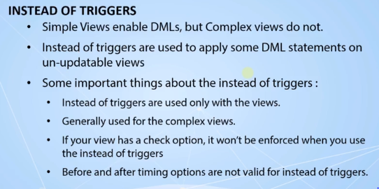

----------------- creating a complex view -----------------

CREATE OR REPLACE VIEW VW_EMP_DETAILS AS

SELECT UPPER(DEPARTMENT_NAME) DNAME, MIN(SALARY) MIN_SAL, MAX(SALARY) MAX_SAL

FROM EMPLOYEES_COPY JOIN DEPARTMENTS_COPY

USING (DEPARTMENT_ID)

GROUP BY DEPARTMENT_NAME;

----------------- updating the complex view -----------------

UPDATE VW_EMP_DETAILS SET DNAME = 'EXEC DEPT' WHERE

UPPER(DNAME) = 'EXECUTIVE';

----------------- Instead of trigger -----------------

CREATE OR REPLACE TRIGGER EMP_DETAILS_VW_DML

INSTEAD OF INSERT OR UPDATE OR DELETE ON VW_EMP_DETAILS

FOR EACH ROW

DECLARE

V_DEPT_ID PLS_INTEGER;

BEGIN

IF INSERTING THEN

SELECT MAX(DEPARTMENT_ID) + 10 INTO V_DEPT_ID FROM DEPARTMENTS_COPY;

INSERT INTO DEPARTMENTS_COPY VALUES (V_DEPT_ID, :NEW.DNAME,NULL,NULL);

ELSIF DELETING THEN

DELETE FROM DEPARTMENTS_COPY WHERE UPPER(DEPARTMENT_NAME) = UPPER(:OLD.DNAME);

ELSIF UPDATING('DNAME') THEN

UPDATE DEPARTMENTS_COPY SET DEPARTMENT_NAME = :NEW.DNAME

WHERE UPPER(DEPARTMENT_NAME) = UPPER(:OLD.DNAME);

ELSE

RAISE_APPLICATION_ERROR(-20007,'You cannot update any data other than department name!.');

END IF;

END;

**Lecture 159 : Exploring and Managing the Triggers**

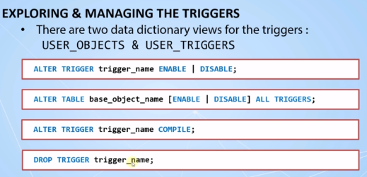

Select * from user_triggers;

**Lecture 160 : Creating Disabled Triggers**

create or replace trigger prevent_high_salary

before insert or update of salary on employees_copy

for each row

disable

when (new.salary > 50000)

begin

raise_application_error(-20006,'A salary cannot be higher than 50000!.');

end;

**Lecture 163 :**

/********************** Creating a Sequence ************************/

CREATE SEQUENCE seq_dep_cpy

START WITH 280

INCREMENT BY 10;

/********************** PRIMARY KEY Example ************************/

CREATE OR REPLACE TRIGGER trg_before_insert_dept_cpy

BEFORE INSERT ON departments_copy

FOR EACH ROW

BEGIN

--SELECT seq_dep_cpy.nextval INTO :new.department_id FROM dual;

:new.department_id := seq_dep_cpy.nextval;

END;

/*******************************************************************/

INSERT INTO departments_copy (department_name,manager_id,location_id)

VALUES('Security',200,1700);

/*******************************************************************/

DESC departments_copy;

/******************** Creating The Audit Log Table *****************/

CREATE TABLE log_departments_copy

(

log_user VARCHAR2(30),

log_date DATE,

dml_type VARCHAR2(10),

old_department_id NUMBER(4),

new_department_id NUMBER(4),

old_department_name VARCHAR2(30),

new_department_name VARCHAR2(30),

old_manager_id NUMBER(6),

new_manager_id NUMBER(6),

old_location_id NUMBER(4),

new_location_id NUMBER(4)

);

/********************** Audit Log Trigger ************************/

CREATE OR REPLACE TRIGGER trg_department_copy_log

AFTER INSERT OR UPDATE OR DELETE ON departments_copy

FOR EACH ROW

DECLARE

v_dml_type varchar2(10);

BEGIN

IF inserting THEN

v_dml_type := 'INSERT';

ELSIF updating THEN

v_dml_type := 'UPDATE';

ELSIF deleting THEN

v_dml_type := 'DELETE';

END IF;

INSERT INTO log_departments_copy

VALUES ( user,

sysdate,

v_dml_type,

:old.department_id,

:new.department_id,

:old.department_name,

:new.department_name,

:old.manager_id,

:new.manager_id,

:old.location_id,

:new.location_id

);

end;

/***** Other SQL Statements Used in This Lecture *****/

INSERT INTO departments_copy (department_name, manager_id,location_id)

VALUES ('Cyber Security', 100, 1700);

SELECT * FROM log_departments_copy;

UPDATE departments_copy

SET manager_id = 200

WHERE department_name = 'Cyber Security';

DELETE FROM departments_copy

WHERE department_name = 'Cyber Security';

**Lecture 164: Compound Triggers**

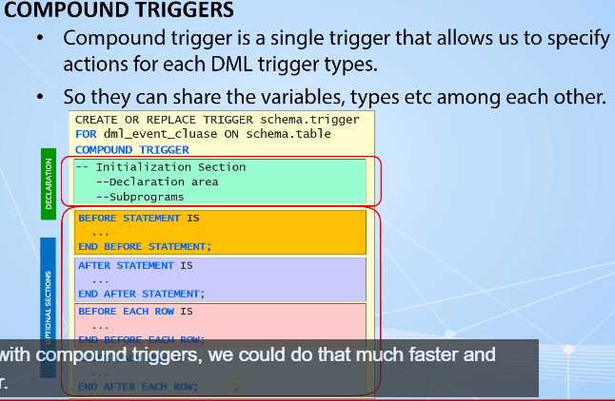

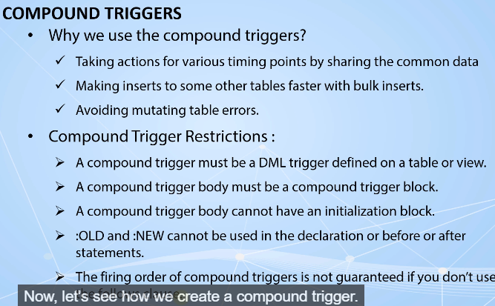

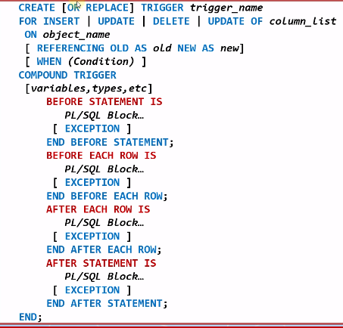

------------------ The first simple compound trigger ----------------

create or replace trigger trg_comp_emps

for insert or update or delete on employees_copy

compound trigger

v_dml_type varchar2(10);

before statement is

begin

if inserting then

v_dml_type := 'INSERT';

elsif updating then

v_dml_type := 'UPDATE';

elsif deleting then

v_dml_type := 'DELETE';

end if;

dbms_output.put_line('Before statement section is executed with the '||v_dml_type ||' event!.');

end before statement;

before each row is

t number;

begin

dbms_output.put_line('Before row section is executed with the '||v_dml_type ||' event!.');

end before each row;

after each row is

begin

dbms_output.put_line('After row section is executed with the '||v_dml_type ||' event!.');

end after each row;

after statement is

begin

dbms_output.put_line('After statement section is executed with the '||v_dml_type ||' event!.');

end after statement;

end;

/*******************************************************************/

CREATE OR REPLACE TRIGGER TRG_COMP_EMPS

FOR INSERT OR UPDATE OR DELETE ON EMPLOYEES_COPY

COMPOUND TRIGGER

TYPE T_AVG_DEPT_SALARIES IS TABLE OF EMPLOYEES_COPY.SALARY%TYPE INDEX BY PLS_INTEGER;

AVG_DEPT_SALARIES T_AVG_DEPT_SALARIES;

BEFORE STATEMENT IS

BEGIN

FOR AVG_SAL IN (SELECT AVG(SALARY) SALARY , NVL(DEPARTMENT_ID,999) DEPARTMENT_ID

FROM EMPLOYEES_COPY GROUP BY DEPARTMENT_ID) LOOP

AVG_DEPT_SALARIES(AVG_SAL.DEPARTMENT_ID) := AVG_SAL.SALARY;

END LOOP;

END BEFORE STATEMENT;

AFTER EACH ROW IS

V_INTERVAL NUMBER := 15;

BEGIN

IF :NEW.SALARY > AVG_DEPT_SALARIES(:NEW.DEPARTMENT_ID) + AVG_DEPT_SALARIES(:NEW.DEPARTMENT_ID)*V_INTERVAL/100 THEN

RAISE_APPLICATION_ERROR(-20005,'A raise cannot be '|| V_INTERVAL|| ' percent higher than

its department''s average!');

END IF;

END AFTER EACH ROW;

AFTER STATEMENT IS

BEGIN

DBMS_OUTPUT.PUT_LINE('All the changes are done successfully!');

END AFTER STATEMENT;

END;

**Lecture 166:Handling Muting Table Errors**

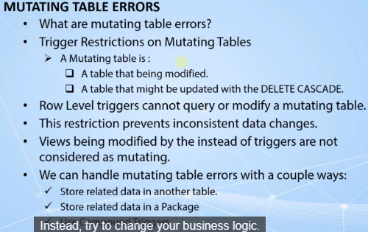

-- A mutating table error example: ----------------------------------

create or replace trigger trg_mutating_emps

before insert or update on employees_copy

for each row

declare

v_interval number := 15;

v_avg_salary number;

begin

select avg(salary) into v_avg_salary from employees_copy where department_id = :new.department_id;

if :new.salary > v_avg_salary*v_interval/100 then

RAISE_APPLICATION_ERROR(-20005, 'A raise cannot be '|| v_interval|| ' percent higher than its department''s average');

end if;

end;

/********************************************************************/

-- Getting mutating table error within a compound trigger: -----------

create or replace trigger trg_comp_emps

for insert or update or delete on employees_copy

compound trigger

type t_avg_dept_salaries is table of employees_copy.salary%type index by pls_integer;

avg_dept_salaries t_avg_dept_salaries;

before statement is

begin

for avg_sal in (select avg(salary) salary,nvl(department_id,999) department_id from employees_copy group by department_id) loop

avg_dept_salaries(avg_sal.department_id) := avg_sal.salary;

end loop;

end before statement;

after each row is

v_interval number := 15;

begin

update employees_copy set commission_pct = commission_pct;

if :new.salary > avg_dept_salaries(:new.department_id)*v_interval/100 then

RAISE_APPLICATION_ERROR(-20005, 'A raise cannot be '|| v_interval|| ' percent higher than its department''s average');

end if;

end after each row;

after statement is

begin

dbms_output.put_line('All the updates are done successfully!.');

end after statement;

end;

/********************************************************************/

-- An example of getting maximum level of recursive SQL levels: ------

create or replace trigger trg_comp_emps

for insert or update or delete on employees_copy

compound trigger

type t_avg_dept_salaries is table of employees_copy.salary%type index by pls_integer;

avg_dept_salaries t_avg_dept_salaries;

before statement is

begin

update employees_copy set commission_pct = commission_pct where employee_id = 100;

for avg_sal in (select avg(salary) salary,nvl(department_id,999) department_id from employees_copy group by department_id) loop

avg_dept_salaries(avg_sal.department_id) := avg_sal.salary;

end loop;

end before statement;

after each row is

v_interval number := 15;

begin

if :new.salary > avg_dept_salaries(:new.department_id)*v_interval/100 then

RAISE_APPLICATION_ERROR(-20005, 'A raise cannot be '|| v_interval|| ' percent higher than its department''s average');

end if;

end after each row;

after statement is

begin

update employees_copy set commission_pct = commission_pct where employee_id = 100;

dbms_output.put_line('All the updates are done successfully!.');

end after statement;

end;

**Lecture 171 : Granting Debug Privileges to a User**

1)You need to connect as the "SYS" or "SYSTEM" user,

2)Execute the following codes to be able to debug your PL/SQL codes & subprograms.

3)You can grant debug privileges to another user by replacing HR within the following codes if you need to.

*******************************************************************/

GRANT DEBUG CONNECT SESSION TO hr;

GRANT DEBUG ANY PROCEDURE TO hr;

BEGIN

dbms_network_acl_admin.append_host_ace

(host=>'127.0.0.1',

ace => sys.xs$ace_type(privilege_list => sys.xs$name_list('JDWP'),

principal_name => 'HR',

principal_type => sys.xs_acl.ptype_db) );

END;

**Lecture 172 :Debugging the Anonymous Blocks**

DECLARE

CURSOR c_emps IS

SELECT * FROM employees_copy;

BEGIN

DBMS_OUTPUT.PUT_LINE('Update started at : '|| systimestamp);

FOR r_emp IN c_emps LOOP

IF NVL(r_emp.commission_pct,0) = 0 THEN

UPDATE employees_copy SET commission_pct = 0.3 WHERE employee_id = r_emp.employee_id;

end if;

END LOOP;

dbms_output.put_line('Update finished at : '|| systimestamp);

ROLLBACK;

END;

**Lecture 174 : Introduction to Dynamic SQL AND Dynamic PL/SQL**

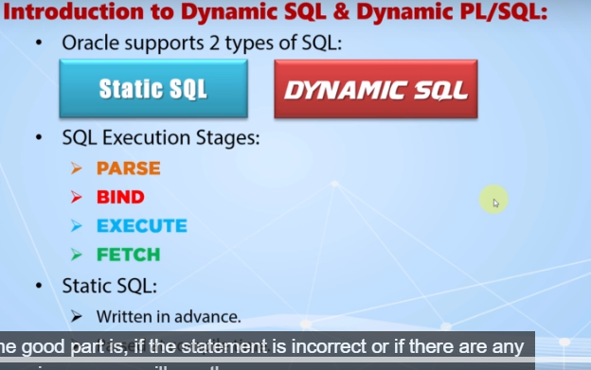

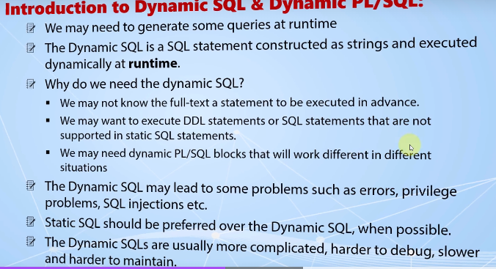

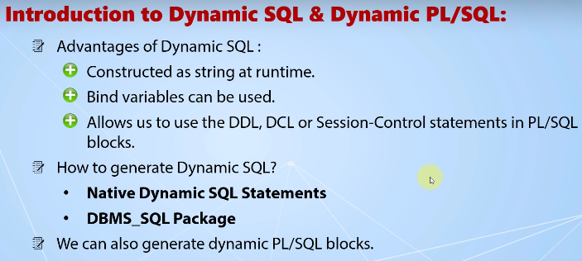

**Lecture 175 : Native Dynamic SQL.PL/SQL**

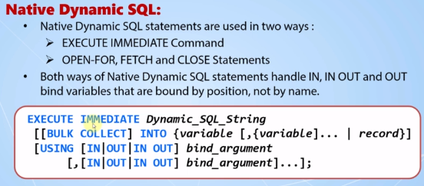

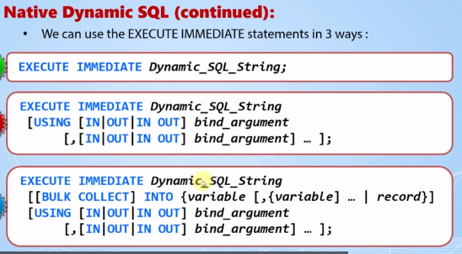

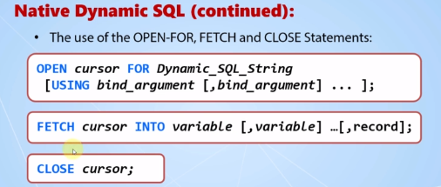

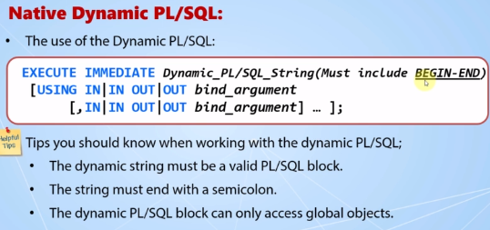

**Lecture 176 : EXECUTE IMMEDIATE Statement**

BEGIN

EXECUTE IMMEDIATE 'GRANT SELECT ON EMPLOYEES TO SYS';

END;

/

BEGIN

EXECUTE IMMEDIATE 'GRANT SELECT ON EMPLOYEES TO SYS;';

END;

/

CREATE OR REPLACE PROCEDURE prc_create_table_dynamic

(p_table_name IN VARCHAR2, p_col_specs IN VARCHAR2) IS

BEGIN

EXECUTE IMMEDIATE 'CREATE TABLE '||p_table_name||' ('||p_col_specs||')';

END;

/

EXEC prc_create_table_dynamic('dynamic_temp_table', 'id NUMBER PRIMARY KEY, name VARCHAR2(100)');

/

SELECT * FROM dynamic_temp_table;

/

CREATE OR REPLACE PROCEDURE prc_generic (p_dynamic_sql IN VARCHAR2) IS

BEGIN

EXECUTE IMMEDIATE p_dynamic_sql;

END;

/

EXEC prc_generic('drop table dynamic_temp_table');

/

EXEC prc_generic('drop procedure PRC_CREATE_TABLE_DYNAMIC');

/

DROP PROCEDURE prc_generic;

**Lecture 179 : EXECUTE IMMEDIATE STATEMENT with the USING Clause (Code Samples)**

EXECUTE IMMEDIATE STATEMENT with the USING Clause (Code Samples)

CREATE TABLE names (ID NUMBER PRIMARY KEY, NAME VARCHAR2(100));

/

CREATE OR REPLACE FUNCTION insert_values (ID IN VARCHAR2, NAME IN VARCHAR2) RETURN PLS_INTEGER IS

BEGIN

EXECUTE IMMEDIATE 'INSERT INTO names VALUES(:a, :b)' USING ID,NAME;

RETURN SQL%rowcount;

END;

/

SET SERVEROUTPUT ON;

DECLARE

v_affected_rows PLS_INTEGER;

BEGIN

v_affected_rows := insert_values(2,'John');

dbms_output.put_line(v_affected_rows|| ' row inserted!');

END;

/

SELECT * FROM names;

/

ALTER TABLE names ADD (last_name VARCHAR2(100));

/

CREATE OR REPLACE FUNCTION update_names (ID IN VARCHAR2, last_name IN VARCHAR2) RETURN PLS_INTEGER IS

v_dynamic_sql VARCHAR2(200);

BEGIN

v_dynamic_sql := 'UPDATE names SET last_name = :1 WHERE id = :2' ;

EXECUTE IMMEDIATE v_dynamic_sql USING last_name, ID;

RETURN SQL%rowcount;

END;

/

DECLARE

v_affected_rows PLS_INTEGER;

BEGIN

v_affected_rows := update_names(2,'Brown');

dbms_output.put_line(v_affected_rows|| ' row updated!');

END;

/

CREATE OR REPLACE FUNCTION update_names (ID IN VARCHAR2, last_name IN OUT VARCHAR2) RETURN PLS_INTEGER IS

v_dynamic_sql VARCHAR2(200);

BEGIN

v_dynamic_sql := 'UPDATE names SET last_name = :1 WHERE id = :2' ;

EXECUTE IMMEDIATE v_dynamic_sql USING IN OUT last_name, ID;

RETURN SQL%rowcount;

END;

/

CREATE OR REPLACE FUNCTION update_names (ID IN VARCHAR2, last_name IN VARCHAR2, first_name OUT VARCHAR2) RETURN PLS_INTEGER IS

v_dynamic_sql VARCHAR2(200);

BEGIN

v_dynamic_sql := 'UPDATE names SET last_name = :1 WHERE id = :2 :3' ;

EXECUTE IMMEDIATE v_dynamic_sql USING last_name, ID, OUT first_name;

RETURN SQL%rowcount;

END;

/

DECLARE

v_affected_rows PLS_INTEGER;

v_first_name VARCHAR2(100);

BEGIN

v_affected_rows := update_names(2,'KING',v_first_name);

dbms_output.put_line(v_affected_rows|| ' row updated!');

dbms_output.put_line(v_first_name);

END;

/

CREATE OR REPLACE FUNCTION update_names (ID IN VARCHAR2, last_name IN VARCHAR2, first_name OUT VARCHAR2) RETURN PLS_INTEGER IS

v_dynamic_sql VARCHAR2(200);

BEGIN

v_dynamic_sql := 'UPDATE names SET last_name = :1 WHERE id = :2 RETURNING name INTO :3' ;

EXECUTE IMMEDIATE v_dynamic_sql USING last_name, ID RETURNING INTO first_name;

RETURN SQL%rowcount;

END;

/

DROP TABLE names;

DROP FUNCTION insert_values;

DROP FUNCTION update_names;

**Lecture 181:** **EXECUTE IMMEDIATE STATEMENT with the USING and INTO Clauses (Code Samples)**

CREATE OR REPLACE FUNCTION get_count (table_name IN VARCHAR2) RETURN PLS_INTEGER IS

v_count PLS_INTEGER;

BEGIN

EXECUTE IMMEDIATE 'SELECT COUNT(*) FROM ' || table_name INTO v_count;

RETURN v_count;

END;

/

SET SERVEROUTPUT ON;

BEGIN

dbms_output.put_line('There are '||get_count('employees')||' rows in the employees table!');

END;

/

DECLARE

v_table_name VARCHAR2(50);

BEGIN

FOR r_table IN (SELECT table_name FROM user_tables) LOOP

dbms_output.put_line('There are '||get_count(r_table.table_name)||' rows in the '||r_table.table_name||' table!');

END LOOP;

END;

/

DECLARE

v_table_name VARCHAR2(50);

BEGIN

FOR r_table IN (SELECT table_name FROM user_tables) LOOP

IF get_count(r_table.table_name) > 100 THEN

dbms_output.put_line('There are '||get_count(r_table.table_name)||' rows in the '||r_table.table_name||' table!');

dbms_output.put_line('It should be considered for partitioning');

END IF;

END LOOP;

END;

/

CREATE TABLE stock_managers AS SELECT * FROM employees WHERE job_id = 'ST_MAN';

/

CREATE TABLE stock_clerks AS SELECT * FROM employees WHERE job_id = 'ST_CLERK';

/

CREATE OR REPLACE FUNCTION get_avg_sals (p_table IN VARCHAR2, p_dept_id IN NUMBER) RETURN PLS_INTEGER IS

v_average PLS_INTEGER;

BEGIN

EXECUTE IMMEDIATE 'SELECT AVG(salary) FROM :1 WHERE department_id = :2' INTO v_average USING p_table, p_dept_id;

RETURN v_average;

END;

/

SELECT get_avg_sals('stock_clerks','50') FROM dual;

/

CREATE OR REPLACE FUNCTION get_avg_sals (p_table IN VARCHAR2, p_dept_id IN NUMBER) RETURN PLS_INTEGER IS

v_average PLS_INTEGER;

BEGIN

EXECUTE IMMEDIATE 'SELECT AVG(salary) FROM '||p_table||' WHERE department_id = :2' INTO v_average USING p_dept_id;

RETURN v_average;

END;

/

SELECT get_avg_sals('stock_managers','50') FROM dual;

/

DROP FUNCTION get_count;

DROP FUNCTION get_avg_sals;

DROP TABLE stock_clerks;

DROP TABLE stock_managers;

**Lecture 182 : Execute IMMEDIATE with BULK Collect INTO CLAUSE**

DECLARE

TYPE t_name IS TABLE OF VARCHAR2(20);

names t_name;

BEGIN

EXECUTE IMMEDIATE 'SELECT distinct first_name FROM employees'

BULK COLLECT INTO names;

FOR i IN 1..names.COUNT LOOP

dbms_output.put_line(names(i));

END LOOP;

END;

/

CREATE TABLE employees_copy AS SELECT * FROM employees;

/

DECLARE

TYPE t_name IS TABLE OF VARCHAR2(20);

names t_name;

BEGIN

EXECUTE IMMEDIATE 'UPDATE employees_copy SET salary = salary + 1000 WHERE department_id = 30 RETURNING first_name INTO :a'

RETURNING BULK COLLECT INTO names;

FOR i IN 1..names.COUNT LOOP

dbms_output.put_line(names(i));

END LOOP;

END;

/

DROP TABLE employees_copy;

**Lecture 185 : PL/SQL Dynamics Blocks**

BEGIN

FOR r_emp in (SELECT * FROM employees) LOOP

dbms_output.put_line(r_emp.first_name||' '||r_emp.last_name);

END LOOP;

END;

/

DECLARE

v_dynamic_text varchar2(1000);

BEGIN

v_dynamic_text := q'[BEGIN

FOR r_emp in (SELECT * FROM employees) LOOP

dbms_output.put_line(r_emp.first_name||' '||r_emp.last_name);

END LOOP;

END;]';

EXECUTE IMMEDIATE v_dynamic_text;

END;

/

DECLARE

v_dynamic_text VARCHAR2(1000);

v_department_id PLS_INTEGER := 30;

BEGIN

v_dynamic_text := q'[BEGIN

FOR r_emp in (SELECT * FROM employees WHERE department_id = v_department_id) LOOP

dbms_output.put_line(r_emp.first_name||' '||r_emp.last_name);

END LOOP;

END;]';

EXECUTE IMMEDIATE v_dynamic_text;

END;

/

DECLARE

v_dynamic_text VARCHAR2(1000);

--v_department_id pls_integer := 30;

BEGIN

v_dynamic_text := q'[DECLARE

v_department_id pls_integer := 30;

BEGIN

FOR r_emp in (SELECT * FROM employees WHERE department_id = v_department_id) LOOP

dbms_output.put_line(r_emp.first_name||' '||r_emp.last_name);

END LOOP;

END;]';

EXECUTE IMMEDIATE v_dynamic_text;

END;

/

CREATE OR REPLACE PACKAGE pkg_temp AS

v_department_id_pkg PLS_INTEGER := 50;

END;

/

DECLARE

v_dynamic_text VARCHAR2(1000);

--v_department_id pls_integer := 30;

BEGIN

v_dynamic_text := q'[BEGIN

FOR r_emp in (SELECT * FROM employees WHERE department_id = pkg_temp.v_department_id_pkg) LOOP

dbms_output.put_line(r_emp.first_name||' '||r_emp.last_name);

END LOOP;

END;]';

EXECUTE IMMEDIATE v_dynamic_text;

END;

/

DECLARE

v_dynamic_text VARCHAR2(1000);

v_department_id PLS_INTEGER := 30;

BEGIN

v_dynamic_text := q'[BEGIN

FOR r_emp in (SELECT * FROM employees WHERE department_id = :1) LOOP

dbms_output.put_line(r_emp.first_name||' '||r_emp.last_name);

END LOOP;

END;]';

EXECUTE IMMEDIATE v_dynamic_text USING v_department_id;

END;

/

DECLARE

v_dynamic_text VARCHAR2(1000);

v_department_id PLS_INTEGER := 30;

v_max_salary PLS_INTEGER := 0;

BEGIN

v_dynamic_text := q'[BEGIN

FOR r_emp in (SELECT * FROM employees WHERE department_id = :1) LOOP

dbms_output.put_line(r_emp.first_name||' '||r_emp.last_name);

if r_emp.salary > :sal then

:sal := r_emp.salary;

end if;

END LOOP;

END;]';

EXECUTE IMMEDIATE v_dynamic_text USING v_department_id, IN OUT v_max_salary;

dbms_output.put_line('The maximum salary of this department is : '||v_max_salary);

END;

/

DECLARE

v_dynamic_text VARCHAR2(1000);

v_department_id PLS_INTEGER := 30;

v_max_salary PLS_INTEGER := 0;

BEGIN

v_dynamic_text := q'[BEGIN

FOR r_emp in (SELECT * FROM employeese WHERE department_id = :1) LOOP

dbms_output.put_line(r_emp.first_name||' '||r_emp.last_name);

if r_emp.salary > :sal then

:sal := r_emp.salary;

end if;

END LOOP;

END;]';

EXECUTE IMMEDIATE v_dynamic_text USING v_department_id, IN OUT v_max_salary;

dbms_output.put_line('The maximum salary of this department is : '||v_max_salary);

EXCEPTION

WHEN OTHERS THEN

dbms_output.put_line('The error is : '||sqlerrm);

END;

/

DECLARE

v_dynamic_text VARCHAR2(1000);

v_department_id PLS_INTEGER := 30;

v_max_salary PLS_INTEGER := 0;

BEGIN

v_dynamic_text := q'[BEGIN

FOR r_emp in (SELECT * FROM employeese WHERE department_id = :1) LOOP

dbms_output.put_line(r_emp.first_name||' '||r_emp.last_name);

if r_emp.salary > :sal then

:sal := r_emp.salary;

end if;

END LOOP;

EXCEPTION

WHEN OTHERS THEN

dbms_output.put_line('The error is : '||SQLERRM);

END;]';

EXECUTE IMMEDIATE v_dynamic_text USING v_department_id, IN OUT v_max_salary;

dbms_output.put_line('The maximum salary of this department is : '||v_max_salary);

END;

/

DROP PACKAGE pkg_temp;

**Lecture 186 : Open – For,FETCH Statement**

DECLARE

TYPE emp_cur_type IS REF CURSOR;

emp_cursor emp_cur_type;

emp_record employees%rowtype;

BEGIN

OPEN emp_cursor FOR 'SELECT * FROM employees WHERE job_id = ''IT_PROG''';

FETCH emp_cursor INTO emp_record;

dbms_output.put_line(emp_record.first_name||emp_record.last_name);

CLOSE emp_cursor;

END;

/

DECLARE

TYPE emp_cur_type IS REF CURSOR;

emp_cursor emp_cur_type;

emp_record employees%rowtype;

BEGIN

OPEN emp_cursor FOR 'SELECT * FROM employees WHERE job_id = :job' USING 'IT_PROG';

FETCH emp_cursor INTO emp_record;

dbms_output.put_line(emp_record.first_name||emp_record.last_name);

CLOSE emp_cursor;

END;

/

DECLARE

TYPE emp_cur_type IS REF CURSOR;

emp_cursor emp_cur_type;

emp_record employees%rowtype;

BEGIN

OPEN emp_cursor FOR 'SELECT * FROM employees WHERE job_id = :job' USING 'IT_PROG';

LOOP

FETCH emp_cursor INTO emp_record;

EXIT WHEN emp_cursor%notfound;

dbms_output.put_line(emp_record.first_name||emp_record.last_name);

END LOOP;

CLOSE emp_cursor;

END;

/

DECLARE

TYPE emp_cur_type IS REF CURSOR;

emp_cursor emp_cur_type;

emp_record employees%rowtype;

v_table_name VARCHAR(20);

BEGIN

v_table_name := 'employees';

OPEN emp_cursor FOR 'SELECT * FROM '||v_table_name||' WHERE job_id = :job' USING 'IT_PROG';

LOOP

FETCH emp_cursor INTO emp_record;

EXIT WHEN emp_cursor%notfound;

dbms_output.put_line(emp_record.first_name||emp_record.last_name);

END LOOP;

CLOSE emp_cursor;

END;

**Lecture 188 : Using the DBMS_SQL Package (The Method 4)**

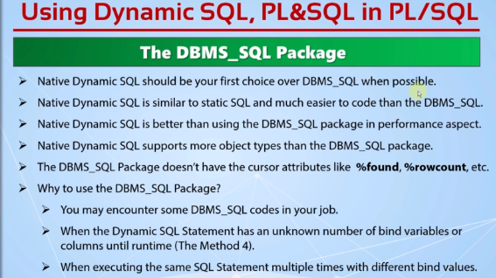

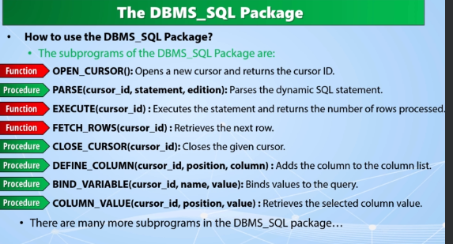

**Lecture 189 : Using the DBMS_SQL Package (Code Samples)**

CREATE TABLE employees_copy AS SELECT * FROM employees;

/

set serveroutput on;

DECLARE

v_table_name VARCHAR2(20) := 'employees_copy';

v_cursor_id PLS_INTEGER;

v_affected_rows PLS_INTEGER;

BEGIN

v_cursor_id := dbms_sql.open_cursor;

dbms_sql.parse(v_cursor_id, 'update '||v_table_name||' set salary=salary+500',dbms_sql.NATIVE);

v_affected_rows := dbms_sql.EXECUTE(v_cursor_id);

dbms_output.put_line(v_affected_rows|| ' rows are updated by dbms_sql!');

dbms_sql.close_cursor(v_cursor_id);

END;

/

select * from employees_copy;

/

DECLARE

v_table_name varchar2(20) := 'employees_copy';

v_cursor_id pls_integer;

v_affected_rows pls_integer;

BEGIN

v_cursor_id := DBMS_SQL.OPEN_CURSOR;

DBMS_SQL.PARSE(v_cursor_id, 'update '||v_table_name||' set salary=salary+500 WHERE job_id = :jid',DBMS_SQL.NATIVE);

DBMS_SQL.BIND_VARIABLE(v_cursor_id, ':jid','IT_PROG');

v_affected_rows := DBMS_SQL.EXECUTE(v_cursor_id);

dbms_output.put_line(v_affected_rows|| ' rows are updated by dbms_sql!');

DBMS_SQL.CLOSE_CURSOR(v_cursor_id);

END;

/

DECLARE

v_table_name varchar2(20) := 'employees_copy';

v_cursor_id pls_integer;

v_affected_rows pls_integer;

BEGIN

v_cursor_id := DBMS_SQL.OPEN_CURSOR;

DBMS_SQL.PARSE(v_cursor_id, 'update '||v_table_name||' set salary=salary+:inc WHERE job_id = :jid',DBMS_SQL.NATIVE);

DBMS_SQL.BIND_VARIABLE(v_cursor_id, ':jid','IT_PROG');

DBMS_SQL.BIND_VARIABLE(v_cursor_id, ':inc','5');

v_affected_rows := DBMS_SQL.EXECUTE(v_cursor_id);

dbms_output.put_line(v_affected_rows|| ' rows are updated by dbms_sql!');

DBMS_SQL.CLOSE_CURSOR(v_cursor_id);

END;

/

SELECT * FROM user_tab_columns;

EXEC prc_method4_example('employees');

EXEC prc_method4_example('departments');

EXEC prc_method4_example('countries');

EXEC prc_method4_example('locations');

/

create or replace PROCEDURE prc_method4_example (p_table_name IN VARCHAR2) IS

TYPE t_columns IS TABLE OF user_tab_columns%rowtype INDEX BY PLS_INTEGER;

v_columns t_columns;

v_columns_with_commas VARCHAR2(32767);

v_number_value NUMBER;

v_string_value VARCHAR2(32767);

v_date_value DATE;

v_output_string VARCHAR2(32767);

cur_dynamic INTEGER;

BEGIN

SELECT * BULK COLLECT INTO v_columns FROM user_tab_columns WHERE table_name = upper(p_table_name);

v_columns_with_commas:=v_columns(1).column_name;

FOR i IN 2..v_columns.COUNT LOOP

v_columns_with_commas:=v_columns_with_commas||','||v_columns(i).column_name;

END LOOP;

cur_dynamic := dbms_sql.open_cursor;

dbms_sql.parse(cur_dynamic,'SELECT '||v_columns_with_commas||' FROM '||p_table_name,dbms_sql.NATIVE);

FOR idx IN 1..v_columns.COUNT LOOP

IF v_columns(idx).data_type = 'NUMBER' THEN

dbms_sql.define_column(cur_dynamic,idx,1);

ELSIF v_columns(idx).data_type IN ('VARCHAR2','VARCHAR','CHAR') THEN

dbms_sql.define_column(cur_dynamic,idx,'dummy text',v_columns(idx).char_length);

ELSIF v_columns(idx).data_type = 'DATE' THEN

dbms_sql.define_column(cur_dynamic,idx,sysdate);

END IF;

v_output_string:=v_output_string||' '||rpad(v_columns(idx).column_name,20);

END LOOP;

dbms_output.put_line(v_output_string);

v_number_value:=dbms_sql.execute(cur_dynamic);

WHILE dbms_sql.fetch_rows(cur_dynamic) > 0 LOOP

v_output_string:=NULL;

FOR t IN 1..v_columns.COUNT LOOP

IF v_columns(T).data_type = 'NUMBER' THEN

dbms_sql.column_value(cur_dynamic,t,v_number_value);

v_output_string := v_output_string||' '||rpad(nvl(to_char(v_number_value),' '),20);

ELSIF v_columns(T).data_type IN ('VARCHAR2','VARCHAR','CHAR') THEN

dbms_sql.column_value(cur_dynamic,t,v_string_value);

v_output_string := v_output_string||' '||rpad(nvl(to_char(v_string_value),' '),20);

ELSIF v_columns(T).data_type = 'DATE' THEN

dbms_sql.column_value(cur_dynamic,t,v_date_value);

v_output_string := v_output_string||' '||rpad(nvl(to_char(v_date_value),' '),20);

END IF;

END LOOP;

dbms_output.put_line(v_output_string);

END LOOP;

END;

**Lecture 190 : What are Oracle – Supplied Packages**

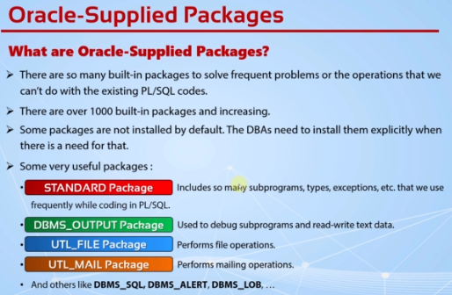

**Lecture 191 : Using the DBMS_OUTPUT Package**

* **This package sends textual data from a PL/SQL block into a buffer in the database.**

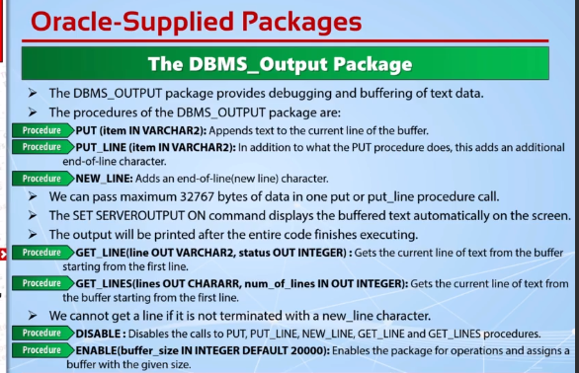

EXEC dbms_output.put_line('Test No:1');

/

SET SERVEROUTPUT ON;

EXEC dbms_output.put_line('Test No:2');

/

EXEC dbms_output.put('Test No:3');

/

EXEC dbms_output.put_line('Test No:4');

/

SET SERVEROUTPUT OFF

/

CREATE TABLE temp_table(ID NUMBER GENERATED ALWAYS AS IDENTITY, text VARCHAR2(1000));

/

EXEC dbms_output.enable;

EXEC dbms_output.put_line('Hi');

/

DECLARE

v_buffer VARCHAR2(1000);

v_status INTEGER;

BEGIN

dbms_output.put('...');

dbms_output.put_line('Hello');

dbms_output.put_line('How are you');

FOR I IN 1..10 LOOP

dbms_output.get_line(v_buffer,v_status);

IF v_status = 0 THEN

INSERT INTO temp_table(text) VALUES (v_buffer);

END IF;

END LOOP;

END;

/

SELECT * FROM temp_table;

/

SET SERVEROUTPUT ON;

DECLARE

v_buffer VARCHAR2(1000);

v_status INTEGER;

BEGIN

dbms_output.put('...');

dbms_output.put_line('Hello');

dbms_output.put_line('How are you');

dbms_output.get_line(v_buffer,v_status);

END;

/

SET SERVEROUTPUT OFF;

EXEC dbms_output.enable;

/

DECLARE

v_buffer dbms_output.chararr;

v_num_lines INTEGER:= 30;

BEGIN

dbms_output.put('...');

dbms_output.put_line('Hello');

dbms_output.put_line('How are you');

dbms_output.get_lines(v_buffer,v_num_lines);

FOR i IN 1..v_num_lines LOOP

INSERT INTO temp_table(text) VALUES (v_buffer(I));

END LOOP;

END;

/

**DROP TABLE temp_table;**

**Lecture 193 : Using the UTL_FILE PACKAGE**

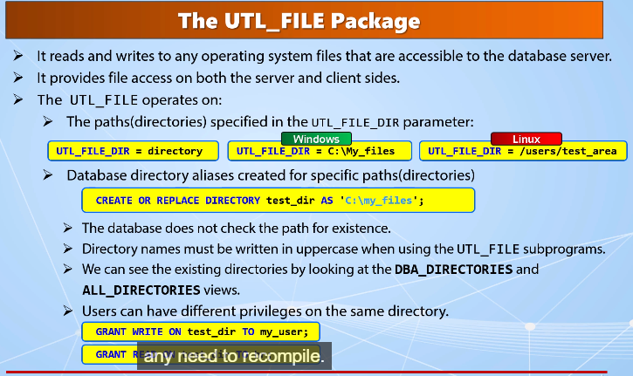

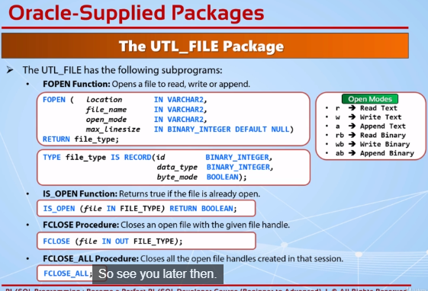

**Lecture 194 : Using the UTL_FILE Package (Part 2)**

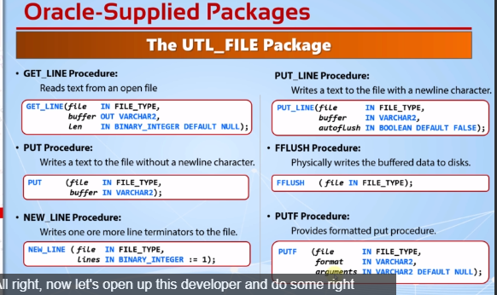

--------------------CREATE DIRECTORY------------------------------------

CREATE DIRECTORY test_dir AS 'C:\My Folder';

/

-------------------GET ALL THE EXISTING DIRECTORIES--------------------

SELECT * FROM all_directories;

/

-------------------READ FROM A FILE------------------------------------

SET SERVEROUTPUT ON;

DECLARE

v_file UTL_FILE.FILE_TYPE;

v_line VARCHAR2(32767);

BEGIN

v_file := UTL_FILE.FOPEN('TEST_DIR', 'temp file.txt', 'R', 32767);

LOOP

UTL_FILE.GET_LINE(v_file, v_line);

dbms_output.put_line (v_line);

END LOOP;

EXCEPTION

WHEN no_data_found THEN

dbms_output.put_line('The whole file is read!');

UTL_FILE.FCLOSE(v_file);

END;

/

-------------------GRANT OR REVOKE READ-WRITE PRIVILEGES---------------

GRANT READ, WRITE ON DIRECTORY test_dir TO hr;

REVOKE READ, WRITE ON DIRECTORY test_dir FROM hr;

/

-------------------WRITE TO A FILE USING PUT_LINE PROCEDURE-------------

DECLARE

v_file UTL_FILE.FILE_TYPE;

BEGIN

v_file := UTL_FILE.FOPEN('TEST_DIR', 'temp file.txt', 'w', 32767);

FOR r_emp IN (select * from employees) LOOP

UTL_FILE.PUT_LINE(v_file, r_emp.first_name||' '||r_emp.last_name);

END LOOP;

UTL_FILE.FCLOSE(v_file);

END;

/

-------------------WRITE TO A FILE USING PUT AND NEW_LINE---------------

DECLARE

v_file UTL_FILE.FILE_TYPE;

BEGIN

v_file := UTL_FILE.FOPEN('TEST_DIR', 'temp file.txt', 'w', 32767);

FOR r_emp IN (select * from employees) LOOP

UTL_FILE.PUT(v_file, r_emp.first_name||' '||r_emp.last_name);

UTL_FILE.NEW_LINE(v_file);

END LOOP;

UTL_FILE.FCLOSE(v_file);

END;

/

-------------------WRITE TO A FILE USING PUTF---------------------------

DECLARE

v_file UTL_FILE.FILE_TYPE;

BEGIN

v_file := UTL_FILE.FOPEN('TEST_DIR', 'temp file.txt', 'w', 32767);

FOR r_emp IN (select * from employees) LOOP

UTL_FILE.PUTF(v_file, '--> %s %s',r_emp.first_name,r_emp.last_name);

--UTL_FILE.NEW_LINE(v_file);

--UTL_FILE.PUTF(v_file, '--> %s %s\n',r_emp.first_name,r_emp.last_name);

END LOOP;

UTL_FILE.FCLOSE(v_file);

END;

/

-------------------USING FFLUSH TO WRITE IMMEDIATELY-------------------

DECLARE

v_file UTL_FILE.FILE_TYPE;

BEGIN

v_file := UTL_FILE.FOPEN('TEST_DIR', 'temp file.txt', 'w', 32767);

FOR r_emp IN (select * from employees) LOOP

UTL_FILE.PUT_LINE(v_file,r_emp.first_name||' '||r_emp.last_name);

--UTL_FILE.FFLUSH(v_file);

--UTL_FILE.PUT_LINE(v_file,r_emp.first_name||' '||r_emp.last_name,true);

DBMS_SESSION.SLEEP(1);

END LOOP;

UTL_FILE.FCLOSE(v_file);

END;

**Lecture 195 : Using the UTL_FILE Package Part3**

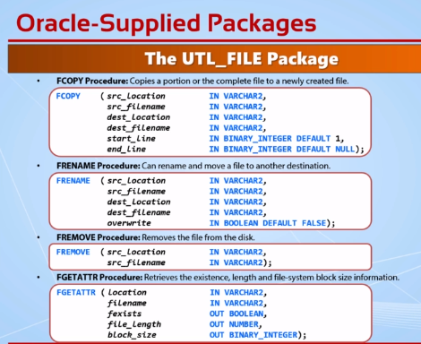

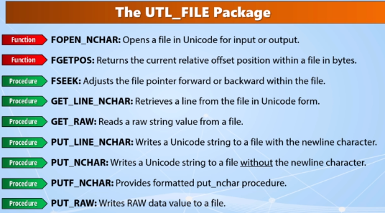

/

-------------------CHECK FILE ATTRIBUTES-----------------------------

DECLARE

v_fexists BOOLEAN;

v_file_length NUMBER;

v_block_size BINARY_INTEGER;

BEGIN

UTL_FILE.FGETATTR('TEST_DIR','temp file.txt',v_fexists,v_file_length,v_block_size);

IF v_fexists THEN

DBMS_OUTPUT.PUT_LINE('The file exists');

DBMS_OUTPUT.PUT_LINE('Its length is :'||v_file_length);

DBMS_OUTPUT.PUT_LINE('Its block size is :'||v_block_size);

ELSE

DBMS_OUTPUT.PUT_LINE('The file does not exist!');

END IF;

END;

/

-------------------COPY THE FILE---------------------------------------

EXECUTE UTL_FILE.FCOPY('TEST_DIR','temp file.txt','TEST_DIR','temp file copy.txt');

/

-------------------COPY THE FILE EX2-----------------------------------

EXECUTE UTL_FILE.FCOPY('TEST_DIR','temp file.txt','TEST_DIR','temp file copy2.txt',1,5);

/

-------------------RENAME THE FILE-------------------------------------

EXECUTE UTL_FILE.FRENAME('TEST_DIR','temp file copy2.txt','TEST_DIR','temp file renamed.txt');

/

-------------------REMOVE THE FILE-------------------------------------

EXECUTE UTL_FILE.FREMOVE('TEST_DIR','temp file renamed.txt');

EXECUTE UTL_FILE.FREMOVE('TEST_DIR','temp file copy.txt');

EXECUTE UTL_FILE.FREMOVE('TEST_DIR','temp file.txt');

/

-------------------DROP THE DIRECTORY-----------------------------------

DROP DIRECTORY test_dir;

**Lecture 197 : Using the UTIL_MAIL Package(Part 1)**

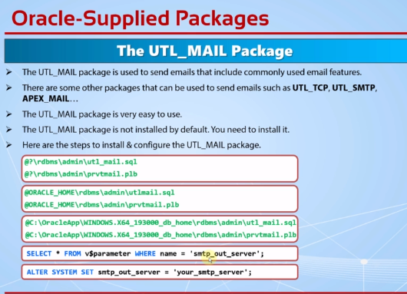

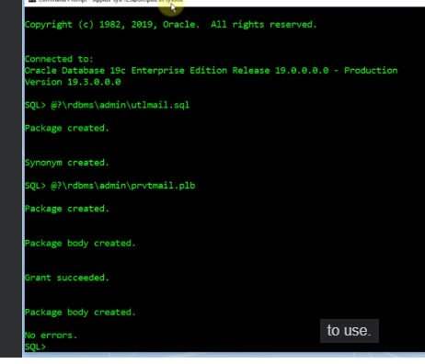



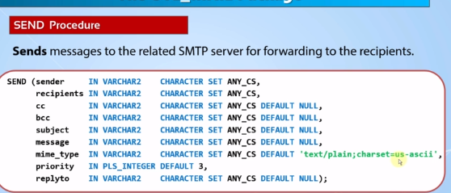

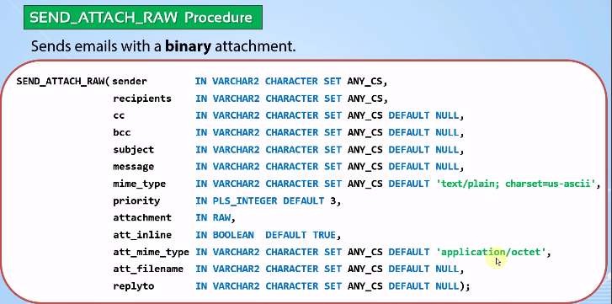

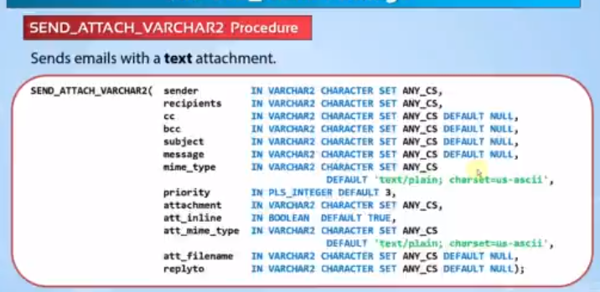

--Sending an email with the least number of parameters

BEGIN

UTL_MAIL.send(

sender => 'somebody@somedomain.com',

recipients => 'oraclemaster@outlook.com',

subject => 'Example 1: Test Email Subject',

message => 'This is a test email from someone.'

);

END;

/

--Sending an email with specific names to the sender and recipients

BEGIN

UTL_MAIL.send(

sender => 'Some Person <somebody@somedomain.com>',

recipients => 'Oracle Masters <oraclemaster@outlook.com>',

subject => 'Example 2: Test Email Subject',

message => 'This is a test email from someone.'

);

END;

/

--Sending an email with using all of the parameters

BEGIN

UTL_MAIL.send(

sender => 'somebody@somedomain.com',

recipients => 'oraclemaster@outlook.com',

cc => 'somemanager@somedomain.something,someotherperson@somedomain.something',

bcc => 'someothermanager@somedomain.com',

subject => 'Example 3: Test Email Subject',

message => 'This is a test email from someone.',

mime_type => 'text/plain; charset=us-ascii',

priority => 1,

replyto => 'somereplyaddress@somedomain.com'

);

END;

/

--Sending an email by dynamically filling the message body

DECLARE

cursor cur_top_earning_emps is

select employee_id, first_name, last_name, salary

from hr.employees

where salary > 10000

order by salary desc;

v_message varchar2(32767);

BEGIN

v_message := 'EMPLOYEE ID'||CHR(9)||'FIRST NAME'||CHR(9)||'LAST NAME'||CHR(9)||'EMPLOYEE ID'||CHR(13);

for r_top in cur_top_earning_emps loop

v_message := v_message||r_top.employee_id||CHR(9)||r_top.first_name||CHR(9)||r_top.last_name||CHR(9)||r_top.salary||CHR(13);

end loop;

UTL_MAIL.send(

sender => 'topearnings@somedns.com',

recipients => 'oraclemaster@outlook.com',

subject => 'Example 4: The Employees Earning More Than $10000',

message => v_message

);

END;

/

--Sending an HTTP mail

DECLARE

cursor cur_top_earning_emps is

select employee_id, first_name, last_name, salary

from hr.employees

where salary > 10000

order by salary desc;

v_message varchar2(32767);

BEGIN

v_message := '<!DOCTYPE html>

<html>

<head>

<meta charset=''Cp1252''>

<title>Top Earning Employees</title>

<meta name="viewport" content="width=device-width, initial-scale=1.0">

<style>

* {

margin: 0;

padding: 0;

}

body {

font: 14px/1.4 Georgia, Serif;

}

/*

Generic Styling, for Desktops/Laptops

*/

table {

width: 100%;

border-collapse: collapse;

}

/* Zebra striping */

tr:nth-of-type(odd) {

background: #eee;

}

th {

background: #333;

color: white;

font-weight: bold;

}

td, th {

padding: 6px;

border: 1px solid #9B9B9B;

text-align: left;

}

@media

only screen and (max-width: 760px),

(min-device-width: 768px) and (max-device-width: 1024px) {

table, thead, tbody, th, td, tr { display: block; }

thead tr { position: absolute;top: -9999px;left: -9999px;}

tr { border: 1px solid #9B9B9B; }

td { border: none;border-bottom: 1px solid #9B9B9B; position: relative;padding-left: 50%; }

td:before { position: absolute;top: 6px;left: 6px;width: 45%; padding-right: 10px; white-space: nowrap;}

/*

Label the data

*/

td:nth-of-type(0):before { content: "EMPLOYEE_ID"; }

td:nth-of-type(1):before { content: "FIRST_NAME"; }

td:nth-of-type(2):before { content: "LAST_NAME"; }

td:nth-of-type(3):before { content: "SALARY"; }

}

}

</style>

<!--<![endif]-->

</head>

<body>

<h1 style = ''text-align :center; color:green;''>Employees Earning more than $10.000 Per/month</h1>

<br>

<table>

<thead>

<tr>

<th>EMPLOYEE_ID</th>

<th>FIRST_NAME</th>

<th>LAST_NAME</th>

<th>SALARY</th>

</tr>

</thead>

<tbody id="data">';

for r_top in cur_top_earning_emps loop

v_message := v_message|| '<tr>'||

'<td align="right">'||r_top.employee_id||'</td>'||

'<td>'||r_top.first_name||'</td>'||

'<td>'||r_top.last_name||'</td>'||

'<td align="right">'||r_top.salary||'</td>'||

'</tr>';

end loop;

v_message := v_message||' </tbody>

</table>

</body>

</html>';

UTL_MAIL.send(

sender => 'topearnings@somedns.com',

recipients => 'oraclemaster@outlook.com',

subject => 'Example 5: The Employees Earning More Than $10000 (HTML Formatted)',

message => v_message,

mime_type => 'text/html'

);

END;

/

------------------SEND ATTACH RAW------------

--Create a temp table

CREATE TABLE temp_table(

id NUMBER,

blob_data BLOB

);

/

--2) Create a directory object

CREATE OR REPLACE DIRECTORY BLOB_DIR AS 'C:\blob_directory\';

/

--3)Write a PL/SQL Block to load your external file into a BLOB/CLOB column.

DECLARE

v_bfile BFILE;

v_blob BLOB;

v_dest_offset INTEGER := 1;

v_src_offset INTEGER := 1;

BEGIN

INSERT INTO temp_table (id, blob_data)

VALUES (222, empty_blob())

RETURNING blob_data INTO v_blob;

v_bfile := BFILENAME('BLOB_DIR', 'test_file.jpeg');

DBMS_LOB.fileopen(v_bfile, DBMS_LOB.file_readonly);

DBMS_LOB.loadblobfromfile (

dest_lob => v_blob, -- Destination lob

src_bfile => v_bfile, -- Source file path and name in the OS

amount => DBMS_LOB.lobmaxsize, -- Maximum LOB size.

dest_offset => v_dest_offset, -- Destination offset.

src_offset => v_src_offset); -- Source offset.

DBMS_LOB.fileclose(v_bfile);

COMMIT;

END;

/

--4) Check the table to see if we could insert the blob file or not

SELECT * FROM temp_table;

/

--5) Send email with an attachment

DECLARE

v_file BLOB;

v_rawbuf RAW(32767);

BEGIN

select blob_data into v_file from temp_table where rownum = 1;

v_rawbuf := dbms_lob.substr(v_file);

UTL_MAIL.send_attach_raw

(

sender => 'somebody@somedomain.com',

recipients => 'oraclemaster@outlook.com',

subject => 'Example 6: Attachment Test',

message => 'This is a raw data',

attachment => v_rawbuf,

att_inline => TRUE,

att_filename => 'testImage.jpeg'

);

END;

/

DROP DIRECTORY blob_dir;

DROP TABLE temp_table;

/

--5) Send email with a text attachment

BEGIN

UTL_MAIL.send_attach_varchar2

(

sender => 'somebody@somedomain.com',

recipients => 'oraclemaster@outlook.com',

subject => 'Example 7: Text Attachment Test',

message => 'This is a text data',

attachment => 'This is the text that will be written inside of the text file.',

att_inline => TRUE,

att_filename => 'testTextFile.txt'

);

END;

**Lecture**

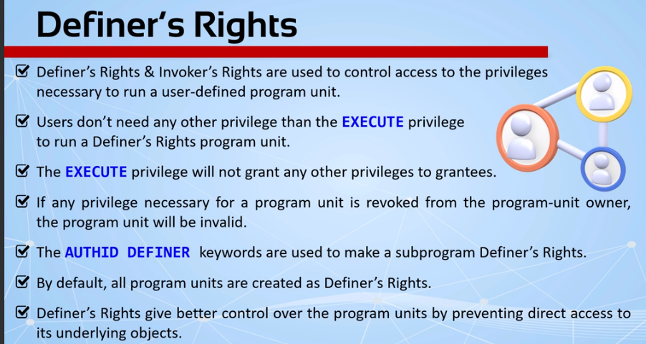

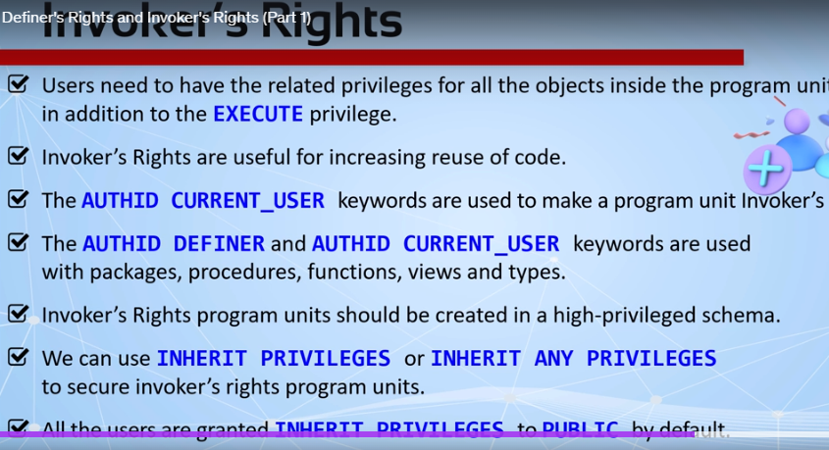

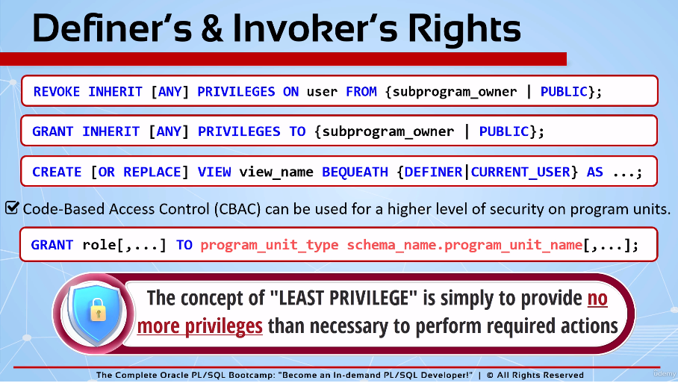

1. - TEMP_USER Worksheet Code
2. CREATE TABLE temp_table (temp_column VARCHAR2(100));
3. /
4. GRANT CREATE PROCEDURE, CREATE VIEW TO temp_user;
5. /
6. CREATE OR REPLACE PROCEDURE insert_into_temp_table (insert_value IN VARCHAR2) IS
7. BEGIN
8. INSERT INTO temp_table VALUES (insert_value);
9. END;
10. /
11. GRANT EXECUTE ON insert_into_temp_table TO hr;
12. /
13. SELECT * FROM temp_table;
14. /
15. EXEC temp_user.insert_into_temp_table('User: TEMP_USER --> Procedure: Definer''s Rights');
16. /
17. CREATE OR REPLACE PROCEDURE insert_into_temp_table (insert_value IN VARCHAR2) AUTHID CURRENT_USER IS
18. BEGIN
19. INSERT INTO temp_table VALUES (insert_value);
20. END;
21. /
22. EXEC temp_user.insert_into_temp_table('User: TEMP_USER --> Procedure: Invoker''s Rights');
23. /
24. SELECT object_name,object_type,status FROM user_objects where object_name = 'INSERT_INTO_TEMP_TABLE';
25. DROP TABLE temp_table;
26. /
27. DROP PROCEDURE insert_into_temp_table;
28. /
29. CREATE TABLE temp_table2 (temp_column VARCHAR2(100));
30. INSERT INTO temp_table2 values('View Test: Temp Table in TEMP_USER');
31. /
32. CREATE OR REPLACE FUNCTION get_last_record_from_temp_table RETURN VARCHAR2 AUTHID CURRENT_USER IS
33. temp_text VARCHAR2(100);
34. BEGIN
35. SELECT temp_column INTO temp_text FROM temp_table2 WHERE ROWNUM = 1;
36. RETURN temp_text;
37. END;
38. /
39. CREATE OR REPLACE VIEW temp_view BEQUEATH DEFINER AS
40. SELECT get_last_record_from_temp_table temp_text FROM dual;
41. /
42. GRANT SELECT ON temp_view TO HR;
43. /
44. CREATE OR REPLACE VIEW temp_view BEQUEATH CURRENT_USER AS
45. SELECT get_last_record_from_temp_table temp_text FROM dual;
46. /
47. DROP VIEW temp_view;
48. DROP FUNCTION get_last_record_from_temp_table;
49. DROP TABLE temp_table2;
51. -- HR USER Worksheet Code:
52. CREATE TABLE temp_table (temp_column VARCHAR2(100));
53. INSERT INTO temp_user.temp_table VALUES ('User: HR --> Direct Insert - INSERT Privilege for Temp_user''s table: No');
54. EXEC temp_user.insert_into_temp_table('User: HR --> Procedure: Definer''s Rights - INSERT Privilege for Temp_user''s table: No');
55. SELECT * FROM temp_table;
56. SELECT * FROM temp_user.temp_table;
57. EXEC temp_user.insert_into_temp_table('User: HR --> Procedure: Invoker''s Rights - INSERT Privilege for Temp_user''s table: No');
58. DROP TABLE temp_table;
59. SELECT * FROM temp_user.temp_view;
60. SELECT * FROM temp_user.temp_table2;